STREAM TEAM FIELD MANUAL

Contents
PROGRAM OVERVIEW 1
DEPLOYMENT PROCEDURES AND SUGGESTED PERSONAL GEAR 2
GENERAL DUTIES FOR STREAM TEAMERS 6
DETAILED PROGRAM FOR SEASONAL ACTIVITIES 8
INSTRUCTIONS FOR OPENING GAGES FOR SEASON 13
FIELD INSTRUCTIONS FOR STREAMWORK 17
INSTRUCTIONS FOR CLOSING OUT GAGES FOR SEASON 18
TROUBLESHOOTING IN THE FIELD 19
INSTRUCTIONS FOR MAKING AN OUTER GAGE/TAPE DOWN MEASUREMENT 21
INSTRUCTIONS FOR MAKING A PORTABLE FLUME MEASUREMENT 22
INSTRUCTIONS FOR MAKING A DISCHARGE MEASUREMENT WITH A PYGMY OR AA METER 24
INSTRUCTIONS FOR FILTERING STREAM CHEMISTRY SAMPLES 27
INSTRUCTIONS FOR CALIBRATING CONDUCTIVITY METERS 28
INSTRUCTIONS FOR CALIBRATING pH METER 29
DATELOGGER PROCEDURES AND COMMANDS 30
SITE LIST 44
REFERENCE POINTS 46
SAMPLE FIELD NOTES 50
DIEL FLOW PATTERNS OF DRY VALLEY STREAMS 56
INDIVIDUAL STREAMGAGE RATING TABLES 57
INSTRUCTIONS FOR SURVEYING LAKE LEVELS 85

PROGRAM OVERVIEW
Information on the hydrology of the dry valley streams is considered essential to a range of research efforts in the McMurdo Dry Valleys. Data is currently being collected on about thirty glacial melt water streams. Seventeen of these streams have instrumentation monitoring them continuously during the flow period. At present, work is conducted mainly in three of the dry valleys – Miers, Taylor, and Wright, with the emphasis on Taylor. Other valleys where streams have been studied include Victoria and Garwood. These streams are generated by glacial melt water during mid-November through mid-February, and typically drain into lakes with no outlets. The names of the lakes involved are Fryxell, Hoare, Bonney, Miers, Vanda, and Vida.
This overview is meant to specifically orient stream team members to their seasonal work in the dry valleys. This manual is a helpful resource, but should not take the place of the USAP Participant’s Guide which is published by NSF every other year. Please also read that book for complete instructions.

DEPLOYMENT PROCEDURES AND SUGGESTED PERSONAL GEAR
Antarctic Support Contract (ASC) is the logistics contractor for the National Science Foundation's (NSF) United States Antarctic Program (USAP). ASC is in charge of support planning, ordering and coordinating equipment supply, personnel deployment, and field support. In March of every year, ASC requests the Support and Information Plan (SIP) be completed by each group funded by NSF to go "to the ice". These SIPs are prepared by the scientists on the MCMLTER project and returned to ASC. Each SIP contains the plan for each group for the upcoming season. From personnel to supplies, to communications needs, to laboratory needs, to field training, the SIP is designed to gather as much information as possible.
Transportation from your point of origin (home) to Antarctica is provided free of charge. Once you have been Physically Qualified (PQ’ed) by ASC, a final departure date will be determined and your plane tickets will be issued. Generally, your flights to New Zealand are confirmed, but your return flight is left open. When you return to Christchurch from the ice, your return trip will be booked and confirmed, and you will receive your return ticket. You are allowed to stay in New Zealand for as long as the Co-PI, Diane or your supervisor (and your visa) allows. When you arrive in New Zealand, you will receive a special 9-month work visa. As far as the visa is concerned, you are in New Zealand for the duration of your stay on the ice. But, as far as New Zealand customs is concerned, you leave New Zealand when you leave for the ice. You will need a passport valid through your return date to the United States. You are required to take your passport with you to Antarctica, and you WILL need it to get back into New Zealand on your return trip. Once ASC has issued your ticket back to your point of origin, you are free to change the route of return, but you will have to do so through the airlines, and you will be charged any fees involved. ASC will only issue you a ticket from Christchurch to your place of origin.
Before deploying, you should fill out a Travel Authorization form, which an INSTAAR accountant can provide. Required (i.e. not vacation) hotel and food costs incurred in CHCH will be reimbursed when you return from the ice.
If you are taking expensive electronic equipment down, you will need to claim it with customs so that you do not have to pay a duty on it on your return. If you are bringing samples back with you from Antarctica, you will need to fill out specific customs forms. Talk to Diane, or whoever is coordinating the SIP.
In recent years, ASC has been routing personnel to Christchurch either through Auckland, New Zealand or Sydney, Australia. These flights can originate in Los Angeles or San Francisco. If routed through Auckland, you will need to claim your baggage, clear customs, and then re-check your baggage for your domestic flight to Christchurch. Then make the 10-minute walk over to the domestic terminal of the airport. A short flight will take you to Christchurch. If routed through Sydney, follow the directions for “connecting international flights” given to you in your travel packet and also from the airline company. Do not leave the Sydney international terminal, as you will have to go through Australian customs in order to board your flight to Christchurch. Once in Christchurch, you can either get a shuttle to the Clothing Distribution Center (CDC) or simply make the 10-minute walk carrying your luggage on an airport dolly. Your travel packet from ASC should have your scheduled time to be at the CDC to pick up your field gear. If you have any questions, ask the CDC staff. Normally, you will be staying at a hotel near downtown Christchurch. They will be familiar with the USAP and participants’ needs. Keep your receipts for reimbursement upon return to the states. There are 2 cheap ways to get there, either the city bus or a cab or shuttle. The bus is cheap, but it may not drop you off close to where you want to be. The shuttle buses are $12 NZD and they will take you right to your hotel. They may not take US$, so change some money at the airport if possible. The shuttles do not take credit cards, as far as I know. Be sure to tell them you are with the USAP for the discounted fare.
You will need to hire a shuttle or take the bus back out to the CDC for your clothing issue. The CDC is very close to the Airport, at the International Antarctic Center. You will also need to take a shuttle or the bus back to your hotel and then back out to the CDC on the day of your flight to the ice. Additional details on where to go and how to do it will be explained to you by ASC support personnel.
You may bring up to two 75-lb. bags plus one 50-lb. carry-on down to New Zealand. As well, you are allowed to bring 150 lbs. of personal gear to the ice. This weight allowance includes about 25lbs of issued gear. If you are also bringing scientific gear, you need to get extra baggage coupons from ASC and permission to bring extra baggage to the ice from New Zealand, also from ASC. Extra gear brought to New Zealand, but not taken to the ice can be stored in Christchurch, free of charge. You will need plenty of gear on the ice, but do not bring more than you need.
When you arrive at the CDC for clothing issue, you will be given a set of gear based on where you will be working, for how long, and your tasks on the ice. You may be able to make a few substitutions to your list. If you explain where you are going, and what you are doing, you may be able to get additional socks, or special other gear (Carhartt clothing, etc.). NSF provides each USAP participant with special cold weather clothing:
1 down parka 2 pair of heavy long underwear
2 pair of wool socks 1 pair of snow bibs
1 warm hat 1 pair of goggles
different types of gloves/mittens 1 pair of bunny boots
1 fleece neck gaiter 2 orange duffel bags
1 wind jacket (ask if not included) 1 fleece jacket
1 light balaclava 1 pair of pile pants (or union suit - very warm)
Try to get extra: 4 pair of socks, 1 or 2 pair long underwear
BE SURE TO TRY EVERYTHING ON AND MAKE SURE IT FITS (items should not bind you when you move). Make sure gloves are properly matched, etc. If the people at the CDC hesitate to give you something, point out politely how long you will be out, that you will not be going back to McMurdo to wash things. Also mention that this list has been given to you by a supervisor experienced in the work you will be doing, and is considered a practical minimum. If they still refuse the "extras", accept it. If they refuse to issue an item at all, try to work out some sort of substitute. Consider bringing one or two extra pairs of long capelene/polypropylene/wool underwear tops and bottoms, as well as thick wool socks with you.
The Stream Team is expected to spend most of its time outdoors, hiking and working. So, you need to bring some other items that are not provided by NSF:

1 large personal duffel bag
1 good pair of sunglasses
1 back-up pair of sunglasses
1 digital watch
personal toiletries
1 good pair of hiking boots
foot powder (if needed)
1 pocket knife
1 pr of light shoes (sneakers)
several T-shirts
underwear
extra long underwear
1 long sleeve shirt
1 laundry bag
long pants (jeans, etc.)
camera, film, batteries
letter writing materials & stamps
extra wool socks
lots of good coffee
sunscreen & lip protection
daily vitamin supply
small battery powered alarm clock
*1 water bottle*

A few comments about the above list:
- Letters and postcards from McMurdo are standard US postage. There is a post office in McMurdo, but we won't be near it often.
- The good pair of sunglasses should be either wrap-arounds or glacier glasses with side-guards. Remember, it is sunny 24-hrs a day and there is an ozone hole, so these will be important. Be sure they fit, and be sure they block UV.
- MAKE SURE YOUR BOOTS ARE BROKEN IN ALREADY. Cuts and bruises don't heal very fast in Antarctica. The best way to cut down on pain is prevention. You will have waders for long stretches in the streams, but often small flows can be measured in just boots. Consider water-proof all-leather boots with good support. You don’t necessarily need mountaineering boots with crampon compatibility, but you will be hiking across unconsolidated terrain with a heavy pack, and sometimes on a glacier.
- Along the same lines, we don't get much fresh food down there. So, supplemental vitamins are important to keeping you healthy.
- Your own warm hat, extra long underwear (maybe 3 pair), and regular underwear (maybe 8 or 9 pair) are advised. You will likely be more comfortable with a change of clothes more often. We will be in the field for 3 months, doing laundry only once or twice during that time. So, recycling is important.
- Remember, you are doing work in the field for a long time. Don't trash your own gear, use theirs. On the other hand, if you are particular about you hat or gloves or underwear, bring it along.
This is pretty much a minimum list of gear you will need to bring to the ice. If you decide to bring more, be sure it fits into one large duffel bag at most. ASC will provide virtually everything you really need to clothe yourself while on the ice. The extras you bring are to either improve on what they give you, or for personal style/preference. Most people will bring a fair bit more than is listed above, as they get tired of wearing the standard issue gear. Assume you cannot buy more consumables (toothpaste, film, etc.) once you leave the states.
You will need to bring sufficient funds to cover your expenses during your travel. Five hundred to one thousand dollars should be available to you during the field season. Expenses incurred in New Zealand will be reimbursed (through the INSTAAR accounting office) after the field season. Traveler's checks, personal checks, credit and debit cards, and cash are all possibilities. You will need to pay for taxis, buses, hotels and meals in New Zealand. BE SURE YOU RETAIN RECEIPTS FOR ALL EXPENSES, OR IT WILL NOT BE POSSIBLE TO REIMBURSE YOU!! In particular, you will need receipts for lodging, and any other business-related expense, except food. You should also keep your airline ticket receipt in the back of the booklet of tickets. If you have credit cards, you will get a superior exchange rate. Otherwise, you will probably need to convert some instruments to Kiwi dollars.
In McMurdo, cash and personal or travelers checks are accepted (The gift shop/liquor store/movie rental/c-store accepts credit cards). Do not count on any specific items to be there. Also, if you wish to consume liquor, you will have to pay for it. You will have to pay for the alcohol you wish to take to the field, and at the several bars that are in town. There are no required expenses on the ice, only optional ones. There is a Wells Fargo ATM machine in the Galley building, but it is not always a reliable source of money.
All food, shelter and medical procedures are provided free of charge while you are on the ice. In McMurdo it may be possible to obtain over the counter medication from the clinic, however, once you are back in New Zealand, any medical costs incurred are your own. You should look into appropriate insurance before you leave the US.
If you want to drink liquor in the field, you will need to make a field liquor pull. The methodology, and stock, are variables so ask around once you get there. If you are joining a team already in the field, they will likely tell you how to do it.
Shipping from CONUS
If you have people back home that want to send you stuff, the address is below.
[Your Name]
McMurdo Station
Project B-506-M
PSC 769 Box 800
APO AP 96599-1035

GENERAL DUTIES FOR STREAM TEAMERS

IN MCMURDO BEFORE DEPLOYING TO THE FIELD
- Establish email communications with Diane McKnight at diane.mcknight@colorado.edu
- Go to Snow School. This will include an overnight course outside of town. As soon as you get to McMurdo, you will be ushered to the chalet, where you will receive an orientation packet. This packet will have your schedule for Snow School. It is possible you will need to be at Snow School at 9 a.m. the morning after you get to McMurdo.
- Receive environmental/waste management training. You will be told the rules on what to do with your garbage. This is required for working in the field camps and you will not be able to leave McMurdo until this is complete.Receive training in truck, ATV and generator operation from MEC.
- Locate all stream-related items ordered on the SIP. If Kathy Welch is in town, find her in the LTER lab (in the Crary lab building) and coordinate efforts with her. If she is not there, do not panic. The Crary staff are very knowledgeable and helpful, so don’t hesitate to ask. Also, email is a wondrous invention that allows you to keep in touch with the outside world. Contact former stream teamers with any questions or concerns, they are your best bet. A third option is to call the Lake Hoare camp and talk to the camp manager there (Probably Rae Spain x3306). The camp manager is especially useful for field camp related questions, but is also familiar with the general stream team routine.
- Pick up field gear at the BFC and arrange to have it brought to the Helo pad to get shipped out to F6 or Lake Hoare field camp.
- Set up an appointment to do a food pull. TIP: stock up on frozen fruits and seafood items, they run out fast! Also, bumper bars are delish.
- Ensure that all stream-related gear is deployed to the proper locations. See further details.
- Receive helicopter safety training (optional). This is covered in Snow School, but it is okay to go down to the helo hanger and talk to the techs there. BE SURE they are not busy though. The helo pad can be a dangerous place. Do what you are told when you are there, and do not wander out on to the pad without a tech or pilot.
- Get your Antarctic Drivers license (optional). There should be info on when you can get this. You will need it to drive a truck around town and pick up various field supplies.

IN THE FIELD, AT START OF SEASON
- Organize stream gear at Lake Hoare Camp. Talk over communication plans with the camp manager. Typically, the camp manager will be in charge of the helo scheduling for the entire LTER team.
- Establish F6 field camp. A carpenter team should have opened it earlier, but you will need to turn on the heater, refrigerators, organize gear, set up tents and radios, etc.
- Open gage boxes. Undo the cargo straps and put them inside the box for use at the end of the season. Clear snow and ice out of gage boxes.
- Clear snow and ice away from control structures.
- Re-establish operation of field gages. Check CR10, batteries, date, time, etc.
- Retrieve previous season’s field data by swapping out storage modules.
- Level reference points before flow starts, as it is hard to do after flow starts, requires carrying more gear and makes gauge visits longer.
DURING FIELD SEASON
- Survey all reference points at gage sites just as flow starts.
- Maintain and calibrate gages.
- Monitor all streams for flow, temperature, specific conductance, pH and chemistry.
- Carry out other planned stream research activities for LTER.
- Assist in research activities of other LTER personnel.

AT END OF FIELD SEASON
- Close out gages, winterize gage boxes (Cargo strap the door shut, the winter is long and severe).
- Survey all reference points at all gages.
- Survey lake levels at selected sites.
- Close out F6 camp.
- Put away gear for winter

IN MCMURDO BEFORE RETURNING TO NEW ZEALAND
- Retro cargo to the USA
- Upload copies of field notes and all data files to CONUS storage location. Make copies of field notes and send to CONUS in container separate from the original notes.

DETAILED PROGRAM FOR SEASONAL ACTIVITIES
IN MCMURDO
When you first arrive in McMurdo, you will need to attend the various training sessions you are required prior to being cleared to deploy to the field. Specific LTER tasks will need to be worked around those sessions.
If you are the first person to arrive in Antarctica on the project, you will need to attend an in-briefing where you will meet select heads of departments, be given a notebook with key contact information and the Research Support Plan (RSP). Additionally, other LTER personnel will advise you where to go to locate equipment or perform various tasks.
Each year, the some of the project's equipment is requested through a SIP. The SIP is then looked over by ASC and certain items are bought, or set aside for the team. In the SIP for B-506, we request specific gage box gear (batteries, etc.), special equipment for experimental work (chemicals, etc.), and typical equipment from the BFC (Berg Field Center) like tents, sleeping bags, and such. All of this is noted in both the SIP and ASC's response to the SIP, the RSP (Research Support Plan). One member from the stream team should have a copy of both the SIP and the RSP with them.
The main task of the team is to move the equipment out to the field, open up the various gages and field camps, and get ready for the "season"; the period when the flow begins. Most streams will not start flowing significantly until December, though some may start as early as the first of November.
If you have any problems, you should ask Kathy Welch. You will also need to dedicate a couple of days to coordinate cleaning and preparing bottles for input/output sets. These are used in the field for collecting water quality samples. Ask Kathy for bottle washing instructions.
The stream team is responsible for opening up the F6 field camp on Lake Fryxell. ASC will de-winterize the building. You will need to ensure that adequate food and other supplies are sent out prior to your arrival. The camp manager at Lake Hoare may want you to take food supplies to F6 from Hoare; you will have to discuss this with her. You will need to go through the SIP, and make sure that equipment is delivered to F6. Consult with other LTER personnel regarding this task.
Fresh nitrogen tanks, and in some cases, batteries, will have to be delivered to all gage locations at some point. Nitrogen tanks need to be okayed for transport, they are considered hazardous cargo, in McMurdo before they can be sent out.
You will definitely need helicopter support to get the tanks to C1, Lake Fryxell, Lake Bonney, and the Onyx River. For individual gages on Lake Fryxell and Bonney, you may decide to drop them all off in one spot (F6 camp, Bonney camp) and distribute them to each gage.
If you plan on staying overnight in Wright Valley: Before departing McMurdo, you should contact the officer in charge at Scott Base, and inquire as to the New Zealand Antarctic Program’s plans for use of the two huts on the Onyx River, and ask them for permission to use the facility. Be sure to let them know you will be servicing the gages, and are working with Clive Howard-Williams (he is a kiwi scientist). This is a courtesy mostly. They will let you use the hut, but you will want to coordinate so you are not at the Lower Wright Hut when they are there especially. The Lower Wright hut is really only big enough for two.

INITIAL TASKS IN THE FIELD
You will deploy first to Lake Hoare field camp. Here, you will need to set up your personal tent, and arrange your personal gear. It is important to deploy to Lake Hoare first so that you can meet up with the camp manager there and coordinate plans for the season. The camp manager at Lake Hoare will be the main point of contact for the LTER group when dealing with helo ops and other important contacts in town (food room, etc.)
After settling in, the next task will be to store away the new items you brought out with you from town. There is a line of crates in back of the chemistry lab which are dedicated to the stream group. The crates nearest the instrument lab contain the equipment most often used by the stream team. There is also gear stored in marked drawers in the instrument and chemistry labs.
The next thing to do will be to open up your first gage. The logical choice is H1 at Andersen Creek, because it is at Lake Hoare Camp.
Once you have opened up the H1 gage, consider a trip across the Canada Glacier to visit the Canada (F1) an Green (F9) Creeks, returning to Lake Hoare Camp around the front of the Canada Glacier. After finalizing work at Lake Hoare, it is time to move to F6 where you will likely be the first group to occupy the camp. From F6 you can open the remaining Fryxell gages.
Each stream team member will establish a tent at this site, which will be left in place for the season. You should leave some extra sleeping gear there as well. Be sure you know the fuel requirements for each machine you use.
Lake Bonney should probably be next, because flow usually starts there first. You will need to schedule one or two nights at Bonney to open the two gages at the lake. These gages will have little if any snow in the controls.
Helicopter Flights:
In general, the best strategy is to use the helos to move heavy gear, or bodies to general areas (F6, Lake Bonney). Once deployed, use ATVs or walk. You should not need a helo to service F1 gage, but you should use one to transport you up to C1, especially if you have tanks or batteries. You can probably walk back to F6 from C1 most of the time.
Always coordinate helo scheduling through the Lake Hoare camp manager, no matter where you are in the valleys. He or she will want to know your plans at least 3 days in advance, so you will have to plan ahead.
Do not get too close to the edge of glaciers. When they calve, it usually happens in a matter of seconds, and an amazing amount of things can come down on your head in a hurry.
You should usually give yourself at least a full day and night when returning to Lake Hoare before planning on traveling to another location. There are a lot of logistics involved in a move, and you don't want to forget anything.

The Onyx River and Miers Valley:
The last sites you should open up are on the Onyx River and in Miers Valley. These locations are remote and take up to 45 minutes to travel to via helicopter. In Wright Valley (location of the Onyx River), you will often get ground time as the helicopter can return to the nearby refueling station and do other support missions while you are working. In Miers Valley, there is often no other group nearby and you will likely receive close support (helicopter and crew will shut down and remain with you at the site).
At these sites, you cannot count on any support facilities in case you forget something. It is therefore important to ensure you have adequate equipment to complete the tasks of the visit.
The gage boxes on the Onyx are top-entry. They are warmer as a result, but harder to get into. You can step on the shelves as you enter, but be careful not to step on the instrumentation. The Miers gages are similar in design to Taylor gages.
Each gage should have two tanks and batteries. You should bring a new tank for each gage on the initial visit. Return the spent tanks to your chosen collection location. Each site should maintain a backup tank since it is so hard to get another one if you are there and something goes wrong. If you do need to use the backup, be sure to replace it on your next visit.
There should be plenty of time to go for a hike along the Onyx if you spend a night at one of the sites. The Lower Wright Hut especially is probably the most secluded place you will be during your visit to Antarctica, and you will hopefully come to think of it as one of the great perks of working on the Stream Team.
You should be able to finish opening all the gages well before the flow has begun. You can then assist other LTER members in their work. Once the rivers start running, you can begin flow-monitoring activities instead.
PROFESSIONAL CONSIDERATIONS
Other Science Camps
While all facilities owned by the United States Antarctic Research Program are available to any American science party, there nonetheless are customary rules of etiquette and conduct expected when a party other than the one responsible for a station uses a facility. The Lake Bonney Camp, while having LTER connections, is still a camp which has been run by S-025 for many years before the LTER, and still is predominantly governed by that project's activities. At least one day's notice should be given before staying overnight, and visitors should haul water, do dishes, and cook when possible or appropriate. The Lake Vanda and Lower Wright Huts are owned by the NZAP. Permission should be obtained from the New Zealand program before using these facilities. Both of these facilities are quite small and lacking basic camp needs beyond the shelter they provide. Do not use any of the supplies in either location unless approved or it is an emergency. You should receive a packet of information on interaction with other groups from Diane McKnight before each season begins. Please read it carefully. It also contains special environmental impact information important to workers in the dry valleys.
Interaction with Antarctic Support Personnel
ASC employs hundreds of tradesmen, administrators, and technicians whose job is to assist science personnel in their activities. As a Stream Team member, you are considered a scientist or “grantee”, and deserving of their support. Stream Team members are expected to treat all ASC employees with respect, and be reasonable in their requests for support. Work with them to achieve your objective, and remember there are other science parties that also need assistance. In most cases, you will be quite pleased with their service if you are reasonable. If you are not, discuss the matter with one of the PI's, never with the ASC employee.
Interaction with Helicopter Support Personnel
The Stream Team spends the greatest amount of time in helicopters within the LTER groups. You will become familiar with the crews and the procedures as the season progresses. However, you should always approach each flight like it is your first. Remember the lessons from your initial training, it will keep you safe and the pilots happy.
1. Be prepared for your helicopter flight. If departing from a camp, the helo can come hours early, and you must be ready for this. The bulk of the gear should be labeled, packed and stagedby the helo pad the night before a flight is scheduled. You should always be capable of stepping into a helo as soon as it lands. NO STREAM TEAM MEMBER HAS EVER BEEN LATE FOR A HELO... DON'T BE THE FIRST.
2. Do what the pilot and crew tell you to. If you aren’t sure of something, stop and ask them. They want you to do the right thing.
3. Assist the helo in landing by standing well upwind of the landing zone at remote sites and pointing downwind at the pad with both arms.
Interaction with Other Scientists
Treat fellow scientists, students and technicians with respect at all times. You might be on the Stream Team, but you are first and foremost a field team member of the LTER. Remember, the idea is to support each other toward a common goal, not to compete.
SUPPORT FACILITIES
Support facilities are located at McMurdo Station, Lake Hoare Camp, Lake Fryxell Camp, Lake Bonney Camp, F6 Camp, Lower Wright Hut, and Lake Vanda Hut, and Miers Lake to a lesser extent. In addition, remote tent camps can be located anywhere as required. A brief description of each facility follows:
McMurdo Station: This is the primary research headquarters of the US Antarctic Program. Peak populations in the summer exceed 1000. Stream Team members will typically spend 7-10 days here when they first arrive on the ice, while preparing for deployment into the dry valleys. McMurdo serves as a training facility, and logistical support for all field camps in the valleys.
Lake Hoare Camp: The Hoare camp is the headquarters for the Long Term Ecological Research Project (LTER). It acts as the communications hub for the LTER, and the main depository for stream gauging equipment in the field. Population ranges from 4 to 20.
Lake Fryxell Camp: This camp will be primarily used by the limno team of the LTER group. It can be used as a temporary camp by stream workers when working on F1 and F2 sites. Lake Fryxell Camp is the traditional target for food raiding parties from F6.
Lake Bonney Camp: This camp is run by John Priscu of the S-025 project, who is also involved with the LTER. Personnel from both projects reside there throughout the season. It is used frequently by the stream workers. Population ranges from 2 to 10.
F6 Camp: Located on Lake Fryxell, this camp is run by LTER personnel. It is home base for the Stream Team members and is frequented by the wormherders. Population ranges from 2 to 6.
Lower Wright Hut: This camp is located on the upper Onyx River. It is owned by the Kiwis, but not usually occupied. It is used periodically by Stream Team members. Population 2 to 4.
Lake Vanda Hut: This camp is located at the mouth of the Onyx River. It is owned by the Kiwis, and periodically occupied by them. It is used periodically by the Stream Team members. Population 2 to 8.
Lake Miers Camp: Located on the shore of Lake Miers, this camp is primarily the infrequent home of the limnological teams. If you plan to overnight, first ensure that you will not interfere with their work.
Most field camps other than Lake Hoare do not have complete, if any, supplies for stream work. It is therefore necessary to bring what is needed along when moving about the dry valleys.

RECOMMENDATIONS FOR WORKING OUT OF REMOTE CAMPS
If visiting a remote hut, ascertain before you go what will be available for your use. If in doubt, bring what you will need.
If you have scheduled a helo for a certain day, check the McMurdo intranet the evening before your expected flight for flight information/times. If you don’t have internet access, you can either contact helo ops on channel 8 around 8 am, or MacOps any time.
Anytime you make a camp move, you are responsible for checking in with MacOps by the pre-arranged time each day. In addition, you are also expected to contact MacOps as soon as you make the camp move to let them know you are there, and can communicate with them. If you fail to check in by a certain time, and attempts to reach you fail, a SAR team will be sent to find you. You DO NOT want to be woken by a SAR team, your continued presence in Antarctica will be reviewed by the LTER and NSF.
No trash of any sort, or body wastes of any kind are allowed to be left in the dry valleys. Plan for it.
Minimize gear on remote work. Use 1 or 2 cooking pots, simplify meals, try to reduce gray water. Take plenty of radio batteries if you know you will not be able to recharge them.
You should bring a first aid kit on all excursions from camp. There is at least one first aid kit allocated for each Stream Team member on the SIP. Additional kits are obtained from the BFC.

INSTRUCTIONS FOR OPENING GAGES FOR SEASON
- Make field notes every time you visit a gage for any purpose on a USGS note!
See example sheets later in this manual. Try to maintain consistency in note taking. When a flow measurement is made, all notes can be made on a discharge record card, a separate site visit note does not need to be filled out.
- Clear the control of ice and snow, free probes and orifice
The control is the location in the stream channel where the instrumentation samples the water. At many sites, there is likely to be drifted in snow and ice there. If the snow is not too deep and hard, take a shovel and clear it away in the vicinity of the center of the channel, and for a few yards downstream. This will allow you to access the probes and orifice tube, and let the water pass through the structure. Do not bother to do this if it looks like it is going to be a lot of work. If it is not too difficult, go ahead and open it up, and let the sun then begin to thaw out the probes and orifice line. Some of the sites will have probes and orifice lines hopelessly frozen in (i.e. H1, Anderson Cr.). DO NOT ATTEMPT TO FREE THEM FROM FROZEN GROUND; YOU WILL DAMAGE THEM. The control structures consist of the section of stream just below the orifice line. It may be a sandbag wall with a flume, a rock dam, or basically a natural channel. DO NOT DISTURB OR "REPAIR" THIS STRUCTURE IN ANY WAY. DOING SO WOULD ALTER THE RELATIONSHIP BETWEEN FLOW DEPTH AND DISCHARGE FOR THAT SITE, AND WE WOULD HAVE TO DEVELOP A NEW RATING FOR THAT SITE.
- Open gage box, clear snow and sediment
Most of the gage boxes have a cargo strap holding them closed. Remove the strap, unlock the door, and open it up. Some of the gages will have a lot of snow and sediment inside. There should be a dustpan and whiskbroom in each one. You should also have a small shovel. Remove the snow and sediment from inside the gage box. BE VERY CAREFUL near the back where the instrumentation is mounted on the wall. There are a number of hoses, pressure lines, and battery connections. If these are damaged, the system will leak or will not operate properly. You could also lose all your nitrogen from your tank. You may want to use the whiskbroom to free them of snow. Coil up the cargo strap, place it in the back of the gage box out of the way for the rest of the season.
- Make communication with the data logger via the keypad.
- CR10x – Connect a free 9-pin connection in the cable coming off of the CR10x to the CR10KD keypad. Don’t disconnect anything, there should be a free port somewhere. Likely, the keypad will display “LOG”. If the keypad is blank, or non-responsive to input, simply power-cycle the CR10x. Don’t worry, they are designed for this and power-cycling will likely “wake up” a CR10x that didn’t have enough power on its initial startup when the sun came up.
- CR1000 – Connect a free 9-pin connection in the cable coming off the CR1000 to the CR1000KD keypad. Same procedure as for the CR10x.
- Retrieve last season's data.
This data will exist on a storage module left in place on the last site visit at the end of the previous season. This data is called “B” data. You should have brought out a set of storage modules to label as you place them. Data from the start of a season and lasting through to the last site visit is called “A” data. It is important to verify that the “B” data is properly labeled before leaving the gage. It is also important to label the new storage module prior to installation. A simple labeling method is <Site_Season_AorB>. For example, “F1_1213_A” is for the “A” data from the 2012-2013 season for the Canada Stream (F1) gage. This naming convention can then be carried over to the actual data file when downloaded to a computer.
CR10x - The storage module with the end of last season's data (“B” data) will be in a velcro holder clip, either mounted on the wall of the gage box, or inside the CR10 enclosure. Remove the storage module by undoing the velcro straps, and if necessary, unscrewing and removing the blue ribbon cable from the storage module. Replace it with the new storage module, and reconnect it as appropriate. Copy the datalogger program to the new module, set data storage method to fill and stop (See page 31 for details). Bring the old storage module back to camp.
CR1000 – The Compact Flash storage device is located in a housing (CFM100) attached to the CR1000 and is accessed by unscrewing the thumb screw. Prior to removal of the CF card, press the “Control” button until the LED light turns solid green. Remove the CF card and replace with a new labeled card. The light will flash red once the new card is installed as the CR1000 is storing all saved data to the new card. The CR1000 will be unresponsive while this occurs. When responsive, copy the datalogger program (located in CPU) to the CRD location.
- Check battery power, and ensure CR10 is properly recording data
- Replace battery, if necessary
Second batteries may need to be added to any of the gages that presently only have one in them, as well as batteries that are probably too old to be out there anymore. Just clip the second battery into the spare pair of leads in the tri-harnesses or into a free port in the power supply manifold. If a battery needs to be charged in camp, there is a nice battery charger at F6 or Lake Hoare for this purpose.
- Reset datalogger time to exact local McMurdo time.
See instructions later in manual on how to set data logger date and time using the *5 command.
WHENEVER YOU ARE THROUGH WORKING WITH THE KEYPAD, HIT *0. IF YOU DO NOT DO THIS, THE DATA LOGGER WILL NOT RECORD ANY DATA. AFTER YOU HIT *0, YOU SHOULD ALWAYS SEE THE DISPLAY "LOG 1".
- Survey control reference points (aka: run levels)
- Replace nitrogen tanks.
Most of the tanks will have been drained of their nitrogen. There is a gage on each one that will show you how much is left. If there is 1000 psi or more, they do not have to be switched. Otherwise, they do.
The Onyx River gages each have a spare in them, but when the first visit is made, a new tank for each should be brought in, and the old one removed back to Lake Hoare. All spent tanks will eventually need to go back to McMurdo, but you should wait to do this until they are all gathered. Any extra full tanks can be left at Lake Hoare camp, or at F6. Be sure all tanks are labeled as full or empty by putting some labeling tape on the outside and writing on it when put away.

To replace a tank:
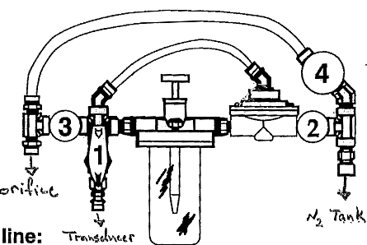
Conoflow:

- Close the valve on the top of the old (empty) tank.
- Close all the valves on the conoflow. Do not over-tighten.
- Close the valve on the regulator. It should be open initially.
- Detach the regulator from the tank with a crescent wrench.
- Put a new tank where the old one was.
- Put Teflon tape around the threads of the regulator. Wrap the tape tightly around the threads of the regulator, 2-3 turns. There should be tape in each gage box in a small box on a shelf.
- Attach the regulator to the new tank with the wrench. This should be pretty snug, but not ridiculous.
- Carefully open the valve on the top of the tank. Do not look at the pressure dial, in the event it explodes. Check for leaks at the connection by liberally applying snoop (as detergent mix) around the threads of the connection.
You will get leakers (as evidenced by bubbles), and they must be dealt with now to prevent premature gas loss, and subsequent data loss. First, apply a little more pressure to the connection with the wrench (make sure you tighten, not loosen). If that doesn’t work, SHUT OFF THE TANK VALVE and remove the connection and try again. If you cannot fix the leak, try another tank.
- If everything seems ok, open the tank valve up the rest of the way, then back it off a half turn. The high pressure gage should read about 2000 psi or so.
- Slowly open the regulator valve. Continue to open valve until the low pressure gage reads about 10 psi.
- Open the valve (#3 in the diagram) where the black orifice line exits the conoflow.
- SLOWLY open the valve (#2 in the diagram) where the green pressure hose attaches to the conoflow.
- SLOWLY open the valve (#1 in the diagram) where the thin clear tube attaches to the conoflow. This leads out to the pressure transducer. Failure to follow this order can force oil into the pressure transducer and destroying it.
- CHECK FOR PRESSURE LEAKS. IF YOU HEAR GAS ESCAPING, AND IT IS NOT OBVIOUS HOW TO FIX IT, CLOSE THE VALVE TO THE NITROGEN TANK AND LEAVE IT ALONE. IT IS BEST TO CONSULT THE LEAD HYDROLOGIST. DO NOT LOSE THE NITROGEN.

To purge the orifice.
- First, record the inside and outside stages to record the “clogged” condition, as this information will be crucial to amend the data prior to the purge.
- Isolate the transducer in the conoflow. Do this by slowly closing valves 1, 2 and 3 in that order.
- Clean away any sediment or algae that might be blocking the orifice.
- Open valve 4 and visually inspect orifice, it should be bubbling vigorously.
- Close valve 4, then slowly open valves 3, 2, and 1 in that order.
- Record the inside and outside stages to record the hopefully “non-clogged” condition.

FIELD INSTRUCTIONS FOR STREAMWORK
Site Visits
- Make out a separate miscellaneous note sheet or field measurement sheet for every site visit.
- Note the date, the initials of the team on the visit, the condition of control, probes, and orifice.
- Also note the weather (cloudy, windy, cold, etc.).
- ALWAYS NOTE WHETHER FLOW IS PRESENT OR NOT!!!
- If anything is out of order, first document the error before attempting to correct it. This ensures that the subsequent data workup back in Colorado will have all the necessary information required.
- Note the tank pressure.
- Make field meter measurements for stage, discharge, water temperature and specific conductance (or conductivity if temperature is low, note which measurement was made), note the datalogger time of each. These measurements should be made in the same location as the in-situ probes they are meant to calibrate.
- Collect stream chemistry samples and note the time of collection. The stream team's work in the field is the best way of monitoring stream chemistry.
  - Choose a location that is near the control structure, which represents the general flow. Label the bottles prior to sample collection with location, date, and time: “F1 011212 1310” for example, is for Canada Stream at gage F1, taken on 12 Jan 2012 at 13:10. This labeling is critical as it will follow the sample through the various analyses to ensue and will identify the sample in the LTER database.
  - Place the sample bottles in flowing water, submerged just beneath the surface. For the plastic input bottle, rinse the cap and bottle three times before filling. For the amber glass DOC bottle, fill the bottle without any rinsing. Do not let water touch your hand or fingers and then go into the bottle. Bring lab gloves and use them. If the water is too shallow to fill the bottle, you can fill the bottle with the cap. Or, dig a small depression in the stream bed and set the bottle within when clear. Be sure to cap the bottles firmly so they do not leak.

INSTRUCTIONS FOR CLOSING OUT GAGES FOR SEASON
- Survey all stream gages. Be very careful with the instrument. You might want to wait until the moat freezes enough to use the snowmobile to transport gear. Be sure to shoot the following points:
- all reference points listed in the field manual
- the tops of orifice nuts if the orifice is not inside a flume
- the tops of the upstream and downstream ends of the flume, opposite corners, one pair is good enough
- the bottom upstream end of the flume
- the low point of the overflow weirs in the cutoff walls (at B2, don't forget there are two sides to shoot)
- the pzf on the control structure for non-flume sites
- use the Reference Points that are "x"'d in the reference point list at the initial shots for the survey
- Take final stream chemistry (sample either at gage closeout or near end of flow cycle) at each stream.
- Closeout gages (see detailed instructions later in this manual)
- normally, you should closeout the gages as close to the end of Lake Hoare camp closeout as is practical for each gage.
- Take final calibration measurements, flow measurement if appropriate. Be sure to note condition of probes, control, etc, as in a normal gage visit.
- Retrieve data and reset storage module for winter season.
- Sweep out the box, and close it up with a cargo strap
- Survey lake levels. See specific instructions in the next section. This can be done as part of the close out of the gages.
- Close F6 camp. Discuss details of this with the Lake Hoare camp manager. Retro appropriate stream gear back to Lake Hoare. Be sure it is in a safe place. Leave the snowmobile sling inside the stream crate outside.
- Organize gear. All stream team gear should be in one of the following locations:
- Designated drawers in the chemistry lab (i.e.: filters, filter equipment, tape, etc.)
- Designated drawers in the instrument lab (i.e.: gage hookups, storage module interfaces, notesheets, light equipment, current meters, etc.)
- In one of the stream crates at Lake Hoare (all remaining stream gear and bottles, with the exception of the raft, electric instruments, storage modules, F6 gear)
- At the F6 camp (some sand bags, sample bottles, and one snowmobile sling)
- In the LTER lab in McMurdo
  - Water temperature, conductivity meters, storage modules, one storage module interface, ribbon cable, RS232 cable, diskettes with programs and other items; items belonging to ASC should be inventoried and a list given to ASC; do not turn them in to them! Put all items in a box, seal them up, and label them for the Stream Team. Put them away in a safe place in the lab (room 106). Also, extra bottle sets may go here, or in the LTER crate line in McMurdo.
- Turned back into ASC
  - The pH meters, empty nitrogen tanks, all gear taken from the BFC and other lab equipment taken from Crary Stockroom.
Do not mix our gear in with any other project team
- Pack your personal gear, and help with general camp closeout (at Lake Hoare).
- Retrieve data from the storage modules. All the data collected in the storage modules needs to be pulled onto a pc, and then the data needs to be cleared in preparation for next season. The next season, these storage modules must be ready to be switched out with the ones that wintered over in the gages.
  - copy the data from the storage module to the pc (see instructions in this manual)
  - ftp raw CR10 data to the database coordinator in Boulder (contact him/her for specific details)
  - erase the data from the storage module only after you are sure that a complete record has been successfully transferred to the database coordinator (see instructions in this manual)
- Save all field data for retro back to the USA. Make copies of all of the site visit and measurement notes and mail them to the database coordinator in Boulder (at INSTAAR 1560 30th St. Campus Box 450 Boulder, CO 80309). Make scans or photos of all the site visit and measurement notes. Take original site visit/measurement sheets and disks with copies of the raw CR10 data with you on your person back to the USA.
- Help Kathy Welch if she needs it, until she says you can go.
- When you get back to the States, you will need to turn in all your receipts, and fill out a travel form for reimbursement. If you are a volunteer for the USGS, you will need to fill out a volunteer time sheet and travel report too.

TROUBLESHOOTING IN THE FIELD
The Program Does NOT Run:
- Check that the battery is connected, and has at least 12.0 volts.
- Check that a program is loaded into the CR10 by hitting *1 and advancing down far enough to see that there are instructions stored. If not, load a new program into the datalogger with the *D command.
There are -99999 or -69999 Values Displayed in *6 Mode:
- Check if the bad values are being stored in the storage module. If they are, the CR10 is probably not receiving a good signal from the sensor. Check each wire where it connects to the CR10 wiring panel, and be sure they are tight. If you still cannot fix it, it could be a problem with the port to which the sensor is attached, or a problem with the sensor itself.
- If it is not just the wire, check open port by inserting a P20 command, port set to 1, set to 5 volts. Check voltage with a multimeter. Rewire leads to the good port. You can check the old port the same way. Pressure transducers can be talked to with the keypad or pc. Interrogate the SDI signal to ensure it is the stage value before the offset.
Values Displayed in *6 Appear Unrealistic:
- If they are probe readings, check the probe to see if it is damaged or buried in sediment. If buried, clean it off and re-deploy it in a better location.
- If probe is bad, replace it. There are spare conductivity/temperature probes at either Lake Hoare or F6.
- If stage readings are high, the line is probably blocked with ice, or maybe dirt. Be sure the line is exposed to the sun as much as possible. You can try purging the line, first isolating the conoflow and transducer at either end. If the weather is cold, leave the line in place until it warms, and check it again. If it is warm, and all else fails, remove the line from the stream, pour hot water on it, especially near the tip. Do not look at the outlet, as ice slivers could shoot out under pressure. Re-deploy after clearing.
- If stage readings are low, you probably have a leak in the system. Check all fittings with snoop, and tighten as required to eliminate the problem.
- Remember, stages will also read high or low to the outside gage if the orifice has moved relative to the control.
There are NO Bubbles Coming Out of the Sight Feed Cup:
- The orifice line is probably frozen. If the stage reading in the *6 command is over 20, this is a virtual certainty. Clear the line, or leave it alone until warmer weather arrives.
There are NO Bubbles Coming Out of the Orifice:
- The line is frozen. Clear it, or leave it alone until it thaws.
The Probes are Buried in Frozen Sediment or Ice:
- Leave alone until it thaws, then move if necessary. A thin layer of sediment will rapidly remove snow and ice in a matter of days.
Water is Flowing Over the Top of the Flume:
- Contact the field hydrologist. You may need to pull out some sandbags.
The Control is Falling Apart:
- If it can be repaired back to its original form, fix it. If not, shore it up so it will not fail further. Document when you did it, and contact the field hydrologist.

INSTRUCTIONS FOR MAKING AN OUTER GAGE/TAPE DOWN MEASUREMENT
An outer gage measurement should be made during every site visit for which the stream is flowing. Without this measurement, discharge measurements (pygmy or flume) are all but useless.
If the control has a flume with a staff plate:
- Record the value at which the water contacts the staff. This is an outer gage measurement, and should be recorded as OG = x.xxx feet. Make a note if:
  - The water enters the flume at an angle
  - The water entering the flume is turbulent
  - The height of water on one side of the flume is higher/lower than on the other.
If the control has no flume:
Record the distance from the top of the rebar (RP) to the water level. This is a tape down, and should be recorded as TD = x.xx feet. You can use the elevation of the top of the RP to subtract the TD from to know the OG for comparison to the IG. But ALWAYS RECORD THE TD as the elevation of the RP will change across the season and the true value is calculated during the workup.
The most accurate recording of a tape down is to set the height of the ruler on the top of the RP and submerge the tip of the ruler and read the water level intersection, as opposed to trying to set the tip at the water level and reading the interection with the top of the RP. For example:
1.0
0.5
0.1
Top of RP is 1.0 ft, water surface is 0.1 ft, therefore the tapedown distance is 1.0 – 0.1 = 0.9 ft.

INSTRUCTIONS FOR MAKING A PORTABLE FLUME MEASUREMENT
The portable 8-inch flumes available to the stream team can measure flows up to about 2.4 cfs (0.5 feet of head). They are therefore suitable for low to moderate flow measurements. Always use the portable flume if possible, as they are quicker and potentially more accurate than the standard current meter measurements at such low flow levels. Keep in mind, however, that though they are relatively quick to use, if the following procedures are not adhered to, the resulting measurements will be erroneous, and there will have been no point in making the measurements at all.
Choose a location that has good "getaway" on the downstream side, if possible, with a fairly narrow section of stream and banks that come up at least a half of a foot. The bottom should consist of either sand or small gravel. There are often locations near each gage where people have obviously done measurements before, and these should be re-used if they appear to look like good spots for the current flow conditions.
Place the flume in the center of the channel, as level as possible from side to side, and point the wing-walls upstream at about a 45 degree angle. Backfill the flume in by piling sand around the front and sides of the flume with a shovel. Be sure to seal the front bottom edge so water cannot leak under the flume. Sand wing walls will usually have to be extended outward to the stream banks to force all the flow through the flume. The entire set up should be inspected for leaks, and further sealed if they exist.
Once the flume is in place, wait for the flow to fill up the storage capacity of the new reservoir you have created upstream of the flume, and for the stages to then level off. This is very critical, and there is a tendency to think the stages are peaked when they are not. Past experience indicates you will not likely be able to make measurements with over 0.5 feet of depth upstream of the flume be for the sand walls collapse.
The next step is to verify that the flume is not submerged by the downstream backwater. If the water level of the stream downstream of the flume is too high, it will affect how deep flow is at the upstream end of the flume, raising it, and the predicted discharge will therefore be higher than it really is. In order to reduce this possibility, you will need to inspect the flow at the downstream end. Normally, there will be a mini hydraulic jump (wave) at the downstream end where the flow slows down and piles up on itself as it exits the flume. This jump should be entirely downstream of the flume. If it is inside the flume, there is a good chance there is at least partial submergence of the flume, and the reading cannot be used. In this case, you will need to try doing the measurement at another location, probably in a steeper section of the streambed.

 |  |  | BASKI,Inc.
Ph. 303-789-1200
Fx. 303-789-0900
Collapsible Cutthroat Flume
 | For free discharge, downstream height ÷ by upstream height must be less than 0.5.
Upstream | cfs |  | Upstream | cfs |  | Upstream | cfs
Gauge (ft) | 8" |  | Gauge (ft) | 8" |  | Gauge (ft) | 8"
0.01 | 0.0004 |  | 0.26 | 0.286 |  | 0.51 | 1.10
0.02 | 0.0017 |  | 0.27 | 0.309 |  | 0.52 | 1.14
0.03 | 0.0038 |  | 0.28 | 0.332 |  | 0.53 | 1.19
0.04 | 0.0068 |  | 0.29 | 0.356 |  | 0.54 | 1.23
0.05 | 0.0106 |  | 0.30 | 0.381 |  | 0.55 | 1.28
0.06 | 0.0152 |  | 0.31 | 0.407 |  | 0.56 | 1.33
0.07 | 0.0207 |  | 0.32 | 0.434 |  | 0.57 | 1.38
0.08 | 0.0270 |  | 0.33 | 0.461 |  | 0.58 | 1.42
0.09 | 0.0342 |  | 0.34 | 0.489 |  | 0.59 | 1.47
0.10 | 0.042 |  | 0.35 | 0.519 |  | 0.60 | 1.52
0.11 | 0.051 |  | 0.36 | 0.549 |  | 0.61 | 1.58
0.12 | 0.061 |  | 0.37 | 0.580 |  | 0.62 | 1.63
0.13 | 0.072 |  | 0.38 | 0.611 |  | 0.63 | 1.68
0.14 | 0.083 |  | 0.39 | 0.644 |  | 0.64 | 1.73
0.15 | 0.095 |  | 0.40 | 0.677 |  | 0.65 | 1.79
0.16 | 0.108 |  | 0.41 | 0.712 |  | 0.66 | 1.84
0.17 | 0.122 |  | 0.42 | 0.747 |  | 0.67 | 1.9
0.18 | 0.137 |  | 0.43 | 0.783 |  | 0.68 | 1.96
0.19 | 0.153 |  | 0.44 | 0.820 |  | 0.69 | 2.02
0.20 | 0.169 |  | 0.45 | 0.857 |  | 0.70 | 2.07
0.21 | 0.187 |  | 0.46 | 0.896 |  | 0.71 | 2.13
0.22 | 0.205 |  | 0.47 | 0.935 |  | 0.72 | 2.19
0.23 | 0.224 |  | 0.48 | 0.975 |  | 0.73 | 2.26
0.24 | 0.244 |  | 0.49 | 1.02 |  | 0.74 | 2.32
0.25 | 0.265 |  | 0.50 | 1.06 |  | 0.75 | 2.38

INSTRUCTIONS FOR MAKING A DISCHARGE MEASUREMENT WITH A PYGMY OR AA METER
If making a current meter measurement, pick a uniform, non-turbulent section with no eddies or cross-flows, or large rocks in the vicinity of the measurement section. If the bulk of the depths are less than 0.25 feet, do not attempt the measurement, but use a flume or estimate by eye.
Some kind of cross-section distance reference (tagline) needs to be laid out across the stream channel, normal to the direction of flow. For very small streams, a six foot folding ruler will work, for larger streams, 50 foot cloth tapes, and for very large streams, like the Onyx River, one of the yellow tag lines on the yellow spools may be necessary. For the folding ruler or cloth tape, orient the lower numbers to the left looking downstream. Lay the tag line out perpendicular to the direction of flow, if possible. You may need to doctor up the section a bit with a shovel, or remove some stones in the way, etc.
If this is at a gage site, hook a keypad up to the CR10, and generally set things up so it will be easy to make inside and outside gage readings quickly.
Fill out the front page of the discharge computation field sheet (who, date, TIME, location, type of meter, etc.). Put together the current meter (pygmy or AA). Be sure to do a spin test before you use it (spin the cups, and watch to see if there is any binding. If there is, readjust the meter until they spin freely.). Connect the meter to the wading rod and headset or electronic counter. If you are using the electronic counter, you will need to be sure there will likely be a strong, reliable signal from the meter throughout the measurement. This is quite likely on the Onyx River when you use the AA, but less likely on some of the smaller, slower streams with high sediment loads. The electronic counter will compute the velocities directly, but we will only use it to count the clicks and the time.
Once everything is ready, you should record the inside and outside gage readings, and the time to the nearest minute. Go back to the tagline, starting on the left bank (as you face downstream) and note the time at the "LEW" (left edge of water). It is very helpful to have a partner sit on shore next to the tagline to take notes, while the other person is in the water making the measurement. You will not likely be able to measure flow at the edge, but you can note the distance on the tagline, and the depth in tenths of feet (or 5 hundredths, if you think better). Once you get out into the flow, you will need to count clicks in a set amount of time. In general, you will set the rod into the water, note the depth on the rod, and set the meter to 0.6 of the depth. If water is generally over 2 feet deep, you will need to set the meter to 0.2 and 0.8 of the depth instead (consult the field hydrologist for the details of this "2 and 8's" technique). If the water is over 1.5 feet deep, you should use the AA meter instead of a pygmy meter. Listen for the end of a click, start the stopwatch, wait 40 seconds or more, stop the watch at the end of a click, and note the number of complete clicks and corresponding time in tenths of a second. If the flow is changing rapidly, you can reduce the time required to 20 seconds (half-counts).
You will want to space the measurements at least 0.3 feet apart for pygmy meters, and 0.5 feet apart for AA meters. If there will be less than 20 vertical sections, this is the spacing you want. If there will be 30 or more, you can consider spacing them out a bit more. The idea is to distribute the flow measured into each vertical as much as possible, so you do not end up with 20 percent of the flow measured in one vertical, for instance. Thus, if the water is relatively deep and/or fast, you would want to reduce the distance on the tag line between verticals in that vicinity. All things being equal however, I would recommend you choose one interval and use it for the entire section, perhaps lengthening it near the edges where it may be slow and shallow.
Once you have reached the REW, note the time, distance and depth. Go back and read the outside gage and time. You can then put the gear away, and finish filling out the field sheet. Be sure to include the following:
- Condition of control as it might affect flow depth (snow/ice (note location and amount), debris, deterioration of structure).
- Rating of measurement- has nothing to do with amount of effort put into the measurement, but everything to do with the conditions. Consider: number of verticals (shoot for 27-30), depth of x-sect (choose sections with all points above 0.30 ft), backwater (choose sections with good flow and little eddying, poor spin tests (minimum for a pygmy is 30secs). More than likely most measurements will be “Poor”, higher flows make “Good” measurements a possibility.
- Point of zero flow (PZF). If at a flow site, note if flow is over low point of weir(s), and if so, how deep it is at the shallowest point on the pzf. If at a non-flume site, note how deep the water is in the shallowest point of the control structure at the upstream edge of the control. Make measurements in tenths of feet.
If you disturbed the stream banks to make the measurement, you should re-level it with a shovel, and attempt to restore it to its original configuration.
You will need to compute the discharges for all meter measurements as the season progresses. See standard USGS methods manual for a description of how to do this, or get instruction from the field hydrologist.
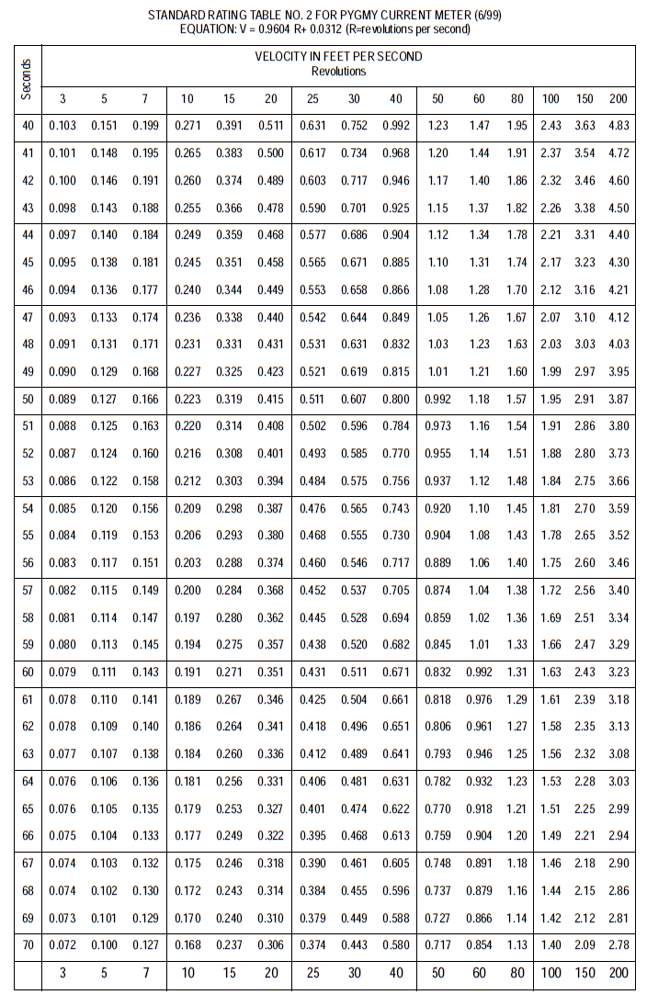

INSTRUCTIONS FOR FILTERING STREAM CHEMISTRY SAMPLES
- Label all the output bottles with the date, time of sample collection, location, and type of sample. Please use the format: streamgageid MM/DD/YYYY hh:mm (ie aiken_f5 01/25/2006 18:25)
- Group output set empty bottles in clusters, in the order they will be filled. i.e.:
Alkalinity - 15mL in smallest bottle
DOC - 100mL in brown glass bottle
Anions - 50mL in wide mouth bottle with blue tape
Cations - 50mL in wide mouth bottle with white tape
Nutrients - 100mL in narrow mouth bottle
Coordinate with Kathy Welch for actual volumes.
- Samples should be filtered within 12 hours of collection. If not, note the time of filtering on the output bottle. If you don't have time to filter everything, the anion/cations can wait.
- Alkalinity - Using the 5 mL pipetter, insert the instrument directly into the bag of clear pipette tips, without touching the tips with your fingers, attach one of the tips to the pipetter. Pipette 5 mL of raw sample into the small vial three times. Be sure not to draw the sample into the tip so fast it splashes back up into the pipette. Pipette a total of 15 mL into the vial, cap it, and place it aside. Remove the tip and discard it. Store in the fridge.
- Anions and Cations -If using the bell jars, place the anion bottle (blue tape, plastic bottle) on the stand, and the bell jar over it. Place a clean tower on the bell jar. Place one of the nucleopore filters (shiny, white) on the tower with forceps, upside down compared to how it comes out of the box. Put the top on the tower, and pour at least 50 mL of raw sample in the tower. Apply a vacuum with the electric or hand pump of 30 psi on the inside scale on the hand pump. When the sample has been filtered, replace the anion bottle with a cation bottle, (white tape, plastic wide mouth bottle), and pour at least 50 mL of raw sample in the tower. If the first filter was clogging badly, first replace it with a new one. Cap both output bottles and store them in the fridge.
- Nutrients - Clean the tower with deionized (DI) water. Place the nutrient bottle inside the bell tower. The nutrient bottle is plastic with a narrow mouth. Place a GF/C filter (in aluminum foil) onto the tower. Pour 100 mL of raw sample in the tower, apply the vacuum, and cap the output bottle. Store the sample in the freezer.
- DOC - Place the DOC bottle inside the bell jar. Change the filter from the nutrient run if necessary. Filter the entire contents of the DOC sample (amber glass bottle) into the output bottle (another amber glass bottle). Open the hydrolochloric acid bottle (keep under the fume hood and use gloves and eye protection: this is concentrated acid). Using the 0.5-mL pipetter, place a 1-mL pipette tip on the pipetter, and pipette 0.1 mL of acid into the DOC bottle. HCL can come in different concentrations so 0.01 mL may work as well. Cap and invert once to mix. It is imperative that pH is between 2-3, so check the pH of the first few of the season to ensure the amount of acid is adequate. You may want to wait until all your DOC samples are filtered before adding acid, so you only have to use one tip for all the work. Discard the tip when finished. Store in the fridge.
- If using the filter flask/hand pump setup instead of the bell jar, you will need to modify the procedure slightly. The anion/cation samples can all be done in one 150-mL aliquot, unless the sample has so much sediment the filter will clog before you can do it all. In that case, you may want to do it in 50 or 75 mL sets, changing the filter each time. Once you have 150 mL, divide the output equally between the anion and cation bottles. Rinse the flask and lower part of the filter tower with DI water, then change to the nutrient filter, and do 75 mL of sample for the nutrient bottle. Fill the nutrient bottle, rinse the flask, change the filter if necessary, and filter the DOC sample for eventual addition to the output bottle.
- Rinse all the filtering equipment that comes in contact with sample with DI water. If items are heavily soiled, you can clean them with kimwipes, and then rinse them. Let the equipment air dry if possible before storing.
- The nutrient samples must be frozen, and the others cannot freeze. Sample fridges at all camps can accommodate these requirements.
- When sufficient sample have been collected (every week during the flow season), contact Kathy Welch in McMurdo to let her know they are coming, pack up the samples in a suitable box and fill out an unaccompanied sample Chain of Custody (COC) form. Let helo ops know you have samples going back to town and they will schedule a helicopter to stop and pick them up. Someone should be there to hand off the boxes and the COC form.

INSTRUCTIONS FOR CALIBRATING CONDUCTIVITY METERS
Check the calibration using conductivity standards to make sure meters are calibrated. You should not have to calibrate the conductivity probes, but if you need to, here’s the information. You could do this at McMurdo before heading to the field if you have access to the probes. If done in the field, there should be some conductivity standards in the Lake Hoare chemistry lab for the stream team. If not, contact Kathy Welch to coordinate getting some. Choose a standard that is in the vicinity of the conductivities you will be measuring in the field. For most streams 50 to 200 uS is adequate, for Lake Bonney's western streams (Blood Falls, Santa Fe, and Lyons) 1000 is better.
- Connect the meter and probe you will be calibrating.
- Rinse the probe in DI water and shake dry. Do not allow the tip to touch anything after rinsing.
- Rinse three small beakers with DI water, and pour the standard solution into each one. You will only need about two inches of depth to take a reading, so do not waste the standard solution.
- Turn the meter on, turn switch to ATC ON, and select a scale that is appropriate for the solution. Note that three of the scales are in milliseimens (mS), and you will need to multiply the reading by 1000 to convert to microseimens (uS), which is what the standard is in. The meter should be in temperature compensation mode – specific conductance should be measured and not conductivity – consult the conductivity meter manual to ensure that you are in the correct mode!
- Place the probe in the first solution for 20 seconds.
- Remove from solution, shake off, and place in second solution for 20 seconds.
- Remove from solution, shake off, and place in third solution. Allow meter to equilibrate for a few seconds, then read the number. With a screwdriver, turn the calibration adjustment screw until the reading matches the standard.
- Repeat process all over again, until the third reading comes within at least 5% of the standard. It should usually be correctly calibrated after the first round.

INSTRUCTIONS FOR CALIBRATING pH METER
NOTE: each year we receive a different pH probe with slightly different calibration instructions. Consult the manual for the probe for specifics. Be sure that for field measurements the pH probe has a built-in temperature adjuster and is hardy enough that it won’t be damaged in the field.
- Connect the pH probe and temperature compensator probe to the meter. Remove the tip guard from the pH probe.
- Completely rinse both probes with DI water, and shake dry.
- Place both probes into pH standard 4 (usually a green colored solution). Be sure the standards have reached room temperature.
- Turn the meter on, and push the calibrate button, and the auto button.
- Wait until the eye stops flashing, and it locks onto the correct reading. Then remove the probes, rinse with DI water again, and place in the pH 7 solution (usually a red colored solution). Hit the calibration button again, and wait for it to lock onto the pH 7 reading.
- Instructions are on the back of the meter, and you can ask other LTER limno team members for help if you have problems.

DATELOGGER PROCEDURES AND COMMANDS
PROCEDURE TO DOWNLOAD DATA FROM A STORAGE MODULE (SM4M)
- Load SMS software on to the pc, if it is not already there, free download from Campbell.
  - On the “SM4M/SM16M” upper tab, select Port “COM1”, Baud Rate “9600”
  - If connecting via a CR10X, check the box and select “CR10X” and Target Address “1”
- Connect the storage module interface (SC532A) to the storage module with the Campbell SC12 cable, and the interface to the pc with the RS232 cable. Make sure you use the correct interface and that it is plugged into AC power. Then use the Campbell software to detect the storage module that is connected to the pc via the interface by clicking the “Connect” button.
- On the “Data” lower tab:
  - File Format is “Comma separated”
  - File Naming Options are [SiteID]_[Season][A or B]. For example, the end of season Canada Stream 1213 season data would be labeled “F1_1213B.dat”
  - Auto Name Control is “Append to Current File”
  - Select the “Get All” button and wait for data to download
  - enter a name the file with the site name, season, and “A” or “B” to denote the beginning or end of the season’s record, i.e.: F1_0910A for the record collected in January 2010 at Site F1.
- On the “Program” lower tab:
  - Select “Prog 8”
  - Click the “Read” button
  - Follow similar naming convention for data files

PROCEDURE TO CLEAR DATA FROM STORAGE MODULE (SM4M)
- **Do not delete data from any storage module until you are sure that a copy exists in the States**
- Load SMS software, connect as above for downloading data.
- Select the “Erase” lower tab
- Select Erase and Test Card
- Quit the application when finished.

PROCEDURE TO COPY A DLD PROGRAM ONTO A STORGE MODULE FROM A PC
If you need to copy a DLD program onto a storage module, always do it in location 8. To do this, run the SMS software as above. Similar to 4) above, select “Prog 8” and click the “Store” button, follow the prompts to upload the correct program.

PROCEDURE TO DOWNLOAD DATA FROM A COMPACT FLASH DRIVE
- Load LoggerNet software, navigate to Data -> CardConvert.
  - “Select the Card Drive…” is straightforward, simple navigate to the card drive.
  - “Change Output Dir…” is similarly straightforward, navigate to destination directory.
  - “Destination File Options…” should be ASCII Table Data (TOA5), no “File Processing” options, no “File Naming” options, UN-select the “Store Record Numbers” option, SELECT the “Store TimeStamp” option
  - “Start Conversion” to begin the download
PROCEDURE TO CLEAR DATA FROM COMPACT FLASH DRIVE
**Do not delete data from any storage module until you are sure that a copy exists in the States**
To format card using Windows Explorer:
1) Insert CF card into CF adapter or CF reader.
2) Windows Explorer should identify a drive as a removable disk (F:\).
3) Select that drive and right click.
4) Choose Format.
COMMAND SEQUENCES FOR CR10X AND STORAGE MODULE (SM) INTERFACE
Note: All command sequences assume you are at a gage, and have the CR10KD keypad connected to the CR10X via the cable. The keypad is a powerful tool that is can program, peruse and delete data as well as provide key diagnostic information if errors occur. As such, the proper usage of the keypad is a critical components of your Stream Team work and understanding its operation is required. For further information, see the following CR10X prompts beginning on page 38.
Any storage modules are also connected onto the array via the ribbon cables. If you have a second storage module that is being used to dump data into from the gage storage module, the convention used for the storage module addressing is always:
gage storage module = 1
travelling storage module = 2

Data collection visits to the gage, where you will be collecting a SM and setting up for either the summer or winter data seasons, will need the following commands:
- Initial check of the date and time of the data logger. Note any discrepancy in your notes and update the clock as needed.
- Check the setting of the new SM, including address, fill and stop mode, and datalogger battery
- Copy the program from the CR10X to the new SM

Normal site visits during the season, where you will be communicating with the CR10X, will need the following commands:
- Changing the scan rate. NOTE: you are actually changing a line of code in the datalogger program when you do this, be sure to revert back to the normal scan rate of 900 seconds (15minutes) before you leave. You could run down the gage power and shut the system down.
- Noting the date and time
- View the storage locations, these are the Inside Gage parameter values you are there to verify.

Changing the Scan Rate:
The scan rate is how long the datalogger waits before it reads the probes and puts out a reading to *6. It is normally set to 900 (seconds, 15 minutes). When you are at a gage, you will need to change it to 10 or 15 seconds while working with the probes, so you can tell what the results of your efforts are without waiting for 15 minutes. When you are through, change the scan back to 900 seconds again before leaving the gage.

Key | Display  ID:Data | Description
*1A | 01:900 | Current datalogger scanrate
XXA | 01:XX | (Change 10 5, 10, or 15 here)
*0 | LOG | This command compiles the program and enables the datalogger to scan the hardware at the new scanrate
***All other operations for the visit***
*1A | 01:XX | Current datalogger scanrate (from above)
900A | 01:900 | Changes the scanrate back to 900 seconds
*0 | LOG | Compiles the program with the original scanrate. This command should always be your last command before leaving the gage.

Checking/Setting Datalogger Time:
Key | Display  ID:Data | Description
*5A | HH:MM:SS | Current datalogger time
A | 05:YYYY | Current datalogger year (Enter the correct year here if necessary)
A | 05:DDD | Current datalogger Julian date (Enter the correct Julian day here if necessary) 1-365 (366 for leap years)
A | 05:HHMM | Current datalogger 24 hour time (Enter the correct time here if necessary)

Viewing the Storage Locations:
To view the datalogger data in real time, you use the *6 command. Each time you hit A, it advances to the next location number, starting with the first. For all gages using a CR10X, the locations and the parameter they represent are uniform. To advance to a far off location, hit *6XXA, where XX is the location number.

Key | Display  ID:Data | Description
*6 | 06:00 | Enter *6 mode
A | 01:XX | Display stage (IG) in ft, IG = Inside Gage
A | 02:XX | Display water temperature (WT) in ºC
A | 03:XX | Display specific conductivity (SC) in μS/cm
A | 04:XX | Display panel temperature (AT) in ºC
A | 05:XX | Display battery voltage (BV) in volts

Changing Memory to Fill and Stop
When a storage module is reset, the memory wiped and automatically set to ring (which means when, full, it starts to overwrite the original data). We always set our storage modules to "fill and stop", to avoid losing data in this way.

Key | Display  ID:Data | Description
*91A | 91:00 | Enter *9 mode, SM address “1”
4A | 04:XX | Display/set memory configuration
1A | 04:01 | Set to fill and stop, data logger will not overwrite existing data
Checking Storage Module Settings
Key | Display  ID:Data | Description
*91A | 91:00 | Enter *9 mode, SM address “1”
5A | 01:ABCD | Display status mode. “AB” not used, “CD” = total MB of data
A | 02:ABCD | “ABC” not used, “D” = number of programs stored (max = 8)  Display should read “02:0001”
A | 03:ABCD | Display should read “03:0010”  “A”=number of errors logged (advanced users)  “B” not used  “C”=memory configuration (0 = ring, 1= fill and stop, should be “1”)  “D”=memory status (0=not full, 1=full)
A | 04:XXXXX | OS signature (advanced users)

If at “03:” you have a 1 in the fourth column, the SM is full and you need to reset the storage module (see end of section for instructions). Every time you reset the storage module, it defaults to the address 1 (that is what we want for gages), and ring memory. Thus you always need to change the memory to fill and stop after resetting an SM.

Determining/Changing Storage Module Addresses:
Key | Display  ID:Data | Description
*9A |  | Enter *9 mode (SM mode)
9A | XX:XXXXXX | Display address of connected SMs. 1 = occupied, 0 = unoccupied. Addresses 8-1 from left to right (87:654321). Example: “00:000001” means one SM is connected, and its address is 1; “00:000011” means two SMs are connected, the gage SM on address 1 and the travelling SM on address 2.
***Changing SM address***

*9A |  | Enter *9 mode (SM mode)
10A | 10:0X | Where X is the current address of the connected SM
YA | 10:0Y | If “X” is incorrect, change to “Y”. This step is generally not necessary in the field, all SMs should be set accordingly when prepared for the field. Do this step only if you are certain it is needed and make certain only one SM is connected when making a change.

Copying the Program from the CR10X to the Gage Storage Module
The new SM should be blank, and you’ll need to load the CR10X program onto the SM. Should the CR10X lose power, it automatically downloads the program in location 8 from the SM and runs that program. Without that program, the CR10X will not run upon power-up.
Key | Display  ID:Data | Description
*D | 13:00 | Enter Save or Load Program mode
71A | 71:00 | “7N” - Store/load/clear program in SM addressed “N”. Here, N =1 for gage SM. This command defines which SM to do the next operation on.
18A |  | “1x” – Save program to location “x” to storage module “N”. Here, x = 8 and N = 1.
 | 13:0000 | After a few seconds, the display will read “13:0000”

To check if program is properly loaded, follow “Checking Storage Module Settings” above. You should see: 02:XXX1 where X is any number, and the "1" indicates the number of programs which are stored in the storage module. This will provide a back up program in the event you lose power to the CR10. All you will need to do is re-establish power, and the program will upload on its own.

Copying the Program to Travelling Storage Module:
Same as above, but the first command should be *D72A instead.

Dumping Data from the Gage Storage Module to the Travelling Storage Module
Key | Display  ID:Data | Description
*8A | 01:XX | Manual Data Dump Mode
72A | 01:72 | Prompt for outpout device address, “7” tells CR10X to send to storage module with address of “2”, the travelling storage module
2A | 02:2 | Start of dump location, basically, this starts at the beginning
A | 03:XXX | You can define the end of the dump location (basically the end of the file), just hitting “A” will dump all data from the start to the finish location “XXX”
 | 04:00 | While dumping, the “04” ID will display with the pointer location incrementing until the transfer is complete. When the numbers stop, the data transfer is complete. Hitting any key during this process will abort the transfer.

Dump Data from the Traveling Storage Module to a PC:
Take the traveling storage module back to camp, and connect it to the pc. Use the SMS software to transfer all the data in the storage module to the hard drive of the pc. Review the contents of the files to ensure the data was properly dumped. The Julian dates are given every 24 hours, as well as the site ids (see table near the end of this manual). The Julian day should start somewhere around 20 or 30, the end of last January for the end of last season's data. If the data do not appear correct, you will need to go back to the gage and try it again. Make two separate copies of all files on CD’s or jump drives.

Checking the Battery Power of the Internal CR10X Battery:
Though the system operates on the external 12v batteries, the CR10X module contains a lithium ion cell battery that operates the clock and SRAM when the CR10X is not connected to an external power source. These batteries should be replaced when voltage is 2.4 or below and this should not be done in the field. (See CR10X manual, section 14.11)
*BA
A Repeatedly enter “A” until “08:XX” is displayed, with XX being the voltage of the internal lithium battery.

Reset Storage Module
If you need to erase the storage module for new data and/or programs, you will need to reset it. Keep in mind that all programs and data will be lost. So, if you need the program again, you should first save the program to another storage module before you do the reset. Be sure the only module connected to the keypad is the one you want to reset. Be extra certain you want to do this, it is rare that a SM is in need of reset in the field, this step should occur prior to deploying the SMs.
*9A
1A
248A

It will take about 1 minute to reset the storage module. When it is done, the display will change.
CR10KD Prompt Sheet and CR10X Overview

Wiring Diagram for CR10X
CR10X (CR1000) | A547 (SC probe interface) | CS547A (SC probe) | 107L (WT probe) | Accubar (Stage sensor)
AG (⏚) | AG
SE3 | SE TEMP
EX2 (VX2) | EX TEMP
EX1 (VX1) | EXCOND
1H | HI COND
1L | LO COND
G | SHIELD
 | SHIELD | Clear
 | TEMP | Red
 | COND | Orange
 | EX COND | Black
 | EX TEMP | Green
EX3 (VX3) |  |  | Black
SE4 |  |  | Red
AG (⏚) |  |  | Purple
G (⏚) |  |  | Clear
12v |  |  |  | PWR+
G |  |  |  | PWR-
C1 |  |  |  | SDI

FIELD GEAR CHECKLIST
(Note: Not all gear on this list will be required for all trips. You use sandbags to hold related items together inside your pack)

Field Items
Safety
handheld radio (VHF) and spare batteries first aid kit
wristwatch set to exact McMurdo time sunscreen

Tool bag
silicon caulk small phillips screwdriver
small flathead screwdriver electric tape
parachute cord wire
pliers/wire cutter hose clamps
solder iron and solder wire stripper (small)
two crescent wrenches, one big enough to tighten nut on tanks

Canvas satchel
field manual multimeter
keypad and ribbon cable pencils
clipboard and fresh field sheets calculator

Field meter bag
pH meter, standards conductivity meter
thermometer DI squirt bottle
sample bottles (input sets, 1 x 250mL nalgene bottle and 1 x amber DOC bottle)
label marker and tape gloves
kimwipes

Discharge equipment
stopwatch pulse counter
spare batteries pygmy meter in case
small screwdriver 50 foot tape
folding ruler headphones
wading rod hip/chest waders
folding ruler for tape-downs

Leveling equipment
auto-level tripod
level rod (standard for streams, metric for lakes) level notes sheet
calculator field manual

FIELD GEAR CHECKLIST (cont’d)

Personal items

Food bag
thermos spoon
hot drink mixes instant soup mixes
freeze dry meals candy bars
water other preferences

Toilet bag
trash bag toilet paper
spare socks/clothes pee bottle/s

Other Random equipment
shovel
AA meter and case
tagline
rock hammer
crampons
ice axe
duct tape

Camping (not usually necessary)
tent, ground cloth earplugs
HF radio sleeping bag
thermarest tent stakes
food spices
garbage bags stove
fuel fuel cans
lighters/matches dish soap
scrubby plastic u-barrel
plastic gray barrel cook pots
fry pan utensils, cups
plates bowls

SITE LIST
Gaged, or previously gaged sites.
Stream Name | Site ID/  Data ID | Gaged | Instruments | Latitude | Longitude
Canada Stream | F1/1 | Yes | stage/wt/sc | -77.6136551 | 163.0547333
Huey Creek | F2/2 | Yes | stage/wt/sc | -77.6048966 | 163.1274109
Lost Seal Stream | F3/3 | Yes | stage/wt/sc/6" flume | -77.5952683 | 163.2444000
Aiken Creek | F5/5 | Yes | stage/wt/sc | -77.6025162 | 163.2719421
McKnight Creek | F4 | No |  | -77.5997238 | 163.2647247
Von Guerard Stream | F6/6 | Yes | stage/wt/sc | -77.6082306 | 163.2536011
Upper Von Guerard Stream | F21 | No |  | -77.6263840 | 163.3012490
Harnish Creek | F7/7 | Yes | stage/wt/sc | -77.6083298 | 163.2327728
Harnish Creek Tributary (Relict Channel) | F11/11 | Yes | wt/sc | -77.6212463 | 163.2695160
Crescent Stream | F8/8 | Yes | stage/wt/sc | -77.6190643 | 163.1844635
Green Creek | F9/9 | Yes | stage/wt/sc | -77.6240997 | 163.0597534
Delta Stream | F10/10 | Yes | stage/wt/sc | -77.6246185 | 163.1084442
Andersen Creek | H1/101 | Yes | stage/wt/sc | -77.6227722 | 162.9063568
House Stream | H2 | No |  | -77.6429825 | 162.7413177
Priscu Stream | B1 | No |  | -77.6999970 | 162.5347290
Santa Fe Stream | B2 | No |  | -77.7230530 | 162.2666626
Lawson Creek | B3/203 | Yes | stage/wt/sc | -77.7227783 | 162.2680511
Lyons Creek | B4 | No |  | -77.7277756 | 162.2749939
Bohner Stream | B5/205 | Yes | stage/wt/sc | -77.6972961 | 162.5636597
Commonwealth Stream | C1/100 | Yes | stage/wt/sc | -77.5633316 | 163.3808289
Onyx River at Vanda | Onyx_Vanda/  302 | Yes | stage/wt/sc | -77.5234299 | 161.6966248
Onyx River at Lower Wright | Onyx_LWRT/  301 | Yes | stage/wt/sc | -77.4445343 | 162.6535339
Adams Stream | M1/401 | Yes | stage/wt/sc | -78.1038097 | 163.7381165
Miers Stream at Outlet | M2/402 | Yes | stage/wt/sc | -78.0995162 | 163.9182378

Non-gaged, but visited sites.
Stream Name | Location | Instruments | Latitude | Longitude
Bowles Creek | Fryxell | No | -77.6222229 | 163.0500031
Mariah Creek | Fryxell | No | -77.6236115 | 163.0472260
Andrews Creek | Fryxell | No | -77.6208344 | 163.0444489
Wharton Creek | Hoare | No | -77.6458359 | 162.7472229
McKay Creek | Hoare | No | -77.6447220 | 162.7472229
Lyons Creek Tributary | Bonney | No | -77.7200012 | 162.2700043
Red River at Blood Falls | Bonney | No | -77.7233353 | 162.2680511
Sharp Creek | Bonney | No | -77.7222214 | 162.2472229
Lizotte Creek | Bonney | No | -77.7041702 | 162.4833374
Bartlette Creek | Bonney | No | -77.7208328 | 162.4166718
Vincent Creek | Bonney | No | -77.7202759 | 162.4250031
Mason Creek | Bonney | No | -77.7291641 | 162.2749939
Marshall Stream | Marshall Valley | No | -78.0660510 | 164.2350440
Garwood Stream below Lake Colleen | Garwood Valley | No | -78.0219830 | 163.9165760
Garwood Stream below Garwood Glacier | Garwood Valley | No | -78.0280520 | 164.1439210

REFERENCE POINTS
Location/name | Description | Elevation (ft)
F1 Canada Str.
(X) RM3 | bolt 110 feet SE of wall, flat gray rock | 7.403
RM4 | bolt 200 feet SSE of wall, rounded rock | 6.946
RP1 | bolt on staff plate (~2.528 ft)
Top of staff plate | Top of staff plate (3.33 ft)
USL flume | Upstream Left, top of flume
DSR flume | Downstream Right, top of flume
PZF flume | Front edge PZF of flume
PZF weir | PZF of overflow weir
F2 Huey Cr.
BM1 | Black “X” atop pink rock, across from gage box, left side
Needs new BMs | Get a rock drill and bolts
RP1 | Top of rebar in channel
F3 Lost Seal Str.
(X) RM3 | bolt right side, downstream of wall | 7.01
RM4 | bolt left side, downstream of wall
RP1 | Top of fence post
Staff plate | Staff plate (top or other feature, not staff plate elevation on sheet)
USL flume | Upstream Left, top of flume
DSR flume | Downstream Right, top of flume
PZF flume | Front edge PZF of flume
PZF weir | PZF of overflow weir
F5 Aiken Cr. | ( *watch out for painted rock here)
(X) BMA | 70 ft Downstream of gage right bank near trail | 10.000
BMB | 70 ft downstream of gage left bank
RP1 | Top of rebar

F6 Von Guerard Str.
(X) BMA | Bolt in rock, upstream of gage, left bank | 6.564
BMB | Bold in rock, downstream of gage, left bank
RP1 | top of rebar in channel | 2.234
F7 Harnish Cr.
(X) RM1 | bolt in flat rock 75 feet left side weir | 10.00
RP1 | top of pipe in channel
F8 Crescent Str.
(X) RM3 | bolt in large rock, left of control | 5.541
RM4 | bolt in channel, ~50 ft upstream | 4.555
RP1 | top of rebar in channel | 4.239
F9 Green Cr.
(X) RM1 | bolt 35 feet right of box | 10.00
RM2 | bolt on right side of wall
RP1 | top of rebar in channel
F10 Delta Str.
(X) RM4 | bolt 100 feet upstream of wall | 10.87
RM3 | bolt 8 feet right side of orifice | Looking upstream left side
RP2 | top rebar in channel
H1 Andersen Str.
(X) RM1 | bolt 225 feet upstream on right on boulder (near NE shore of Dirty Little Hoare), very long shot | 9.568
RM2 | bolt in rock just upstream of flume
RM3 = T011 | bolt in rock, downstream right side, used in algal transect
B3 Lawson Cr.
(X) RM1 | bolt 6 feet downstream of box | 10.00
RP1 | top of rebar

B5 Bohner Str.
(X) BM(A) | Bolt 10’ US Gauge Box | 9.423
BM(B) | Bolt 30’ DSL | -1.37
RP | Top of Post | 4.6
C1 Commonwealth Str.
(X) RM1 | bolt 30 feet downstream right side | 10.00
RP2 | bolt in rock 11 feet upstream, horizontal
RP3 | top of rebar in channel
Onyx River at Lower Wright Weir
(X) BM ASGARD | bolt in large boulder to left of gage | 8.436
BM A (large pinkish rock w/3 bolts, and a karn, use highest bolt) | bolt in rock upstream left side (highest bolt in rock, 200 ft. upstream?)
Top of steel post | 10 m upstream on left side of stream (first surveyed Dec, 1998)
Screw in Staff | Hold at 1.670 ft
PZF | Low point on control
Orifice Nut | Hold top of orifice nut
Onyx River at Lake Vanda Weir
(X) BM6 | bolt in rock on left side, upstream of gage (near karn) | 6.496
BM8 | bolt in rock on left side, downstream of gage (about 100+ ft. away from river)
BM Weir | plate set in rock on left side, downstream of weir (near karn)
Screw in Staff | Hold at 1.476 ft
PZF | Low point on control
Orifice Nut | Top of orifice nut
M1 Adams Str.
BM North | Bolt in rock, 20 ft downstream right | 6.20
BM South | Bold in rock, 50 ft downstream left
RP1 | Top of rebar/post

M2 Miers Str.
BM Kiwi | Bolt sleeve, 50 ft downstream right | 4.36
BM USAP | Bold in rock, left side of stream, across from gage box | ~7.635
RP1 | Top of allthread in stream

SAMPLE FIELD NOTES
Start of season and running levels:
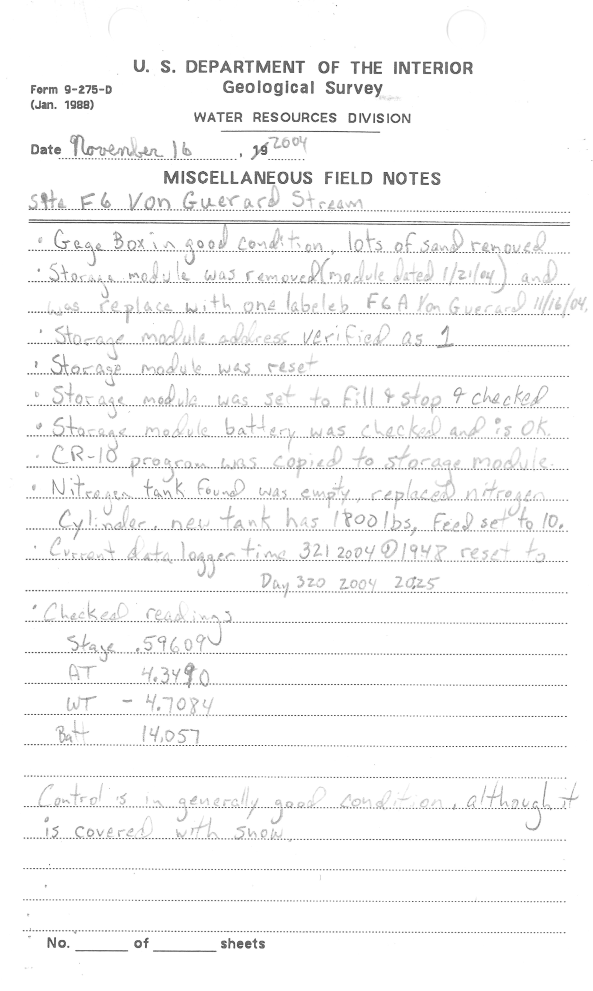
ONLY 1 STREAM PER NOTE!!!!!
Regular site visit:

Regular Discharge Measurement
Final comment about taking notes: it is always better to have MORE information, so use these examples as the minimum amount of information to record.

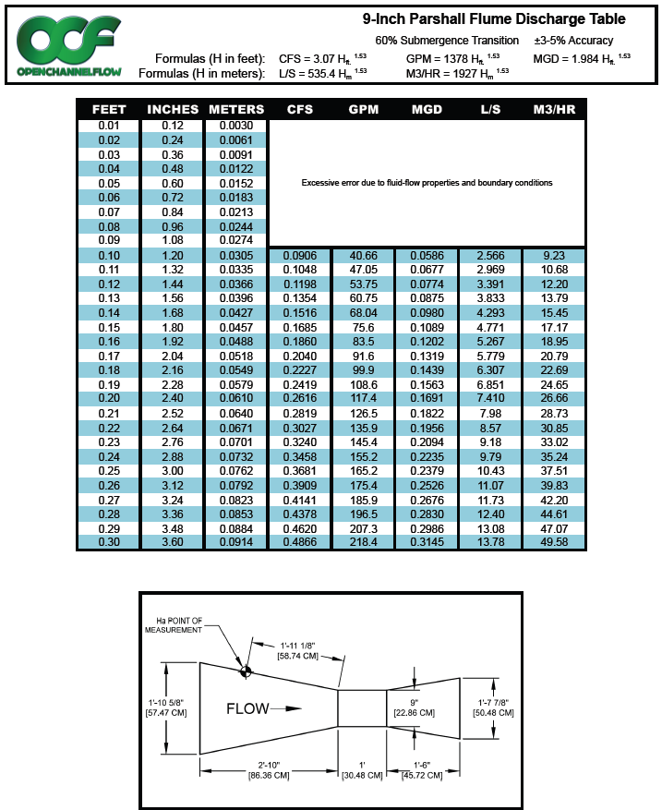

DIEL FLOW PATTERNS OF DRY VALLEY STREAMS
Stream | Beginning season High | Beginning season low | Warming time | Cooling time
Aiken F5 | 2400 | 1300 | 1100 | 1300
Anderson H1 | 1630 | 1100 | 530 | 1870
Canada F1 | 1600 | 700 | 900 | 1500
Common C1 | 1530 | 600 | 930 | 1470
Crescent F8 | 2300 | 1500 | 800 | 1600
Delta F10 | 2100 | 1500 | 600 | 1800
Green F9 | 2100 | 630 | 1470 | 930
Harnish F7 | 1730 | 700 | 1030 | 1370
House H2 | 1500 | 630 | 870 | 1530
Huey F2 | 1700 | 500 | 1200 | 1200
Lawson B3 | 1230 | 300 | 930 | 1470
Lost Seal F3 | 2300 | 1400 | 900 | 1500
Onyx Lwr Wright | 1000 | 400 | 600 | 1800
Onyx Vanda high Q | 1000 | 400 | 600 | 1800
Onyx Vanda low Q | 1930 | 730 | 1200 | 1200
Priscu B1 | 1430 | 530 | 900 | 1500
Von Guerrard F6 | 2200 | 1500 | 700 | 1700

INDIVIDUAL STREAMGAGE RATING TABLES
STATION NUMBER F1 CANADA STREAM AT F1, LAKE FRYXELL, ANTARCTICA SOURCE AGENCY:
Rating for Discharge (ft^3/s)
RATING ID: 3.1 TYPE: Unknown EXPANSION: STATUS: Approved
Created by admin on 09/19/2012 @ 05:32:48 UTC, Updated by scrisp on 10/17/2013 @ 18:04:00 UTC
Remarks:
Offset1: 1.00
Stage (ft) Discharge (ft^3/s) DIFF IN Q PER
.00 .01 .02 .03 .04 .05 .06 .07 .08 .09 .1 UNITS

1.00 0.0000*0.0033 0.0067 0.0100*0.0186 0.0300*0.0366 0.0432 0.0500*0.0597 0.070
1.10 0.0700*0.0810 0.0926 0.1048 0.1174 0.1305 0.1441 0.1582 0.1727 0.1877 0.133
1.20 0.2031 0.2189 0.2351 0.2517 0.2687 0.2861 0.3039 0.3220 0.3405 0.3594 0.175
1.30 0.3786 0.3982 0.4181 0.4383 0.4589 0.4798 0.5010 0.5226 0.5444 0.5666 0.210
1.40 0.5891 0.6119 0.6349 0.6583 0.6820 0.7059 0.7302 0.7547 0.7795 0.8046 0.241

1.50 0.8300*0.8558 0.8818 0.9082 0.9348 0.9617 0.9888 1.016 1.044 1.072 0.270
1.60 1.100* 1.125 1.150 1.175 1.200* 1.232 1.265 1.298 1.332 1.366 0.300
1.70 1.400* 1.449 1.498 1.549 1.600* 1.648 1.697 1.746 1.797 1.848 0.500
1.80 1.900* 1.947 1.995 2.044 2.093 2.143 2.193 2.244 2.295 2.347 0.500
1.90 2.400* 2.457 2.514 2.573 2.632 2.691 2.752 2.813 2.874 2.937 0.600

2.00 3.000* 3.114 3.230 3.350 3.474 3.600* 3.697 3.795 3.895 3.997 1.100
2.10 4.100* 4.219 4.341 4.464 4.591 4.719 4.851 4.984 5.120 5.259 1.300
2.20 5.400* 5.531 5.663 5.798 5.935 6.074 6.215 6.358 6.503 6.650 1.400
2.30 6.800* 6.950 7.103 7.257 7.414 7.573 7.734 7.897 8.062 8.230 1.600
2.40 8.400* 8.580 8.763 8.949 9.137 9.328 9.521 9.718 9.916 10.12 1.920

2.50 10.32 10.53 10.74 10.95 11.17 11.38 11.60 11.83 12.05 12.28 2.200
2.60 12.52 12.75 12.99 13.23 13.47 13.72 13.97 14.22 14.48 14.74 2.480
2.70 15.00* 15.32 15.65 15.98 16.32 16.66 17.00 17.36 17.71 18.08 3.440
2.80 18.44 18.82 19.20 19.58 19.97 20.37 20.77 21.17 21.59 22.00 3.990
2.90 22.43 22.86 23.29 23.74 24.18 24.64 25.10 25.56 26.04 26.51 4.570

3.00 27.00* 27.56 28.13 28.71 29.29 29.89 30.49 31.11 31.73 32.36 6.010
3.10 33.01 33.66 34.32 34.99 35.67 36.36 37.06 37.78 38.50 39.23 6.960
3.20 39.97 40.73 41.49 42.27 43.05 43.85 44.66 45.47 46.30 47.15
"*" indicates a rating descriptor point

STATION NUMBER F3 LOST SEAL STREAM AT F3, LAKE FRYXELL, ANTARCTICA SOURCE AGENCY:
Rating for Discharge (ft^3/s)
RATING ID: 5.0 TYPE: Unknown EXPANSION: STATUS: Approved
Created by admin on 09/20/2012 @ 15:36:57 UTC, Updated by scrisp on 10/21/2013 @ 18:45:39 UTC
Remarks: Extension of rating #4
Offset1: 1.00
Stage (ft) Discharge (ft^3/s) DIFF IN Q PER
.00 .01 .02 .03 .04 .05 .06 .07 .08 .09 .1 UNITS

1.00 0.0000* 0.0040 0.0080 0.0120 0.0160 0.0200* 0.0267 0.0341 0.0421 0.0508 0.060
1.10 0.0600* 0.0698 0.0801 0.0909 0.1140 0.1263 0.1390 0.1522 0.1658 0.1798 0.134
1.20 0.1943 0.2091 0.2244 0.2400 0.2562* 0.2729 0.2899 0.3073 0.3251 0.3433 0.168
1.30 0.3618 0.3807 0.4000 0.4206* 0.4417 0.4632 0.4850 0.5073 0.5300 0.5531 0.215
1.40 0.5766 0.6005 0.6495 0.6746 0.7000 0.7287 0.7579* 0.7876 0.8179 0.8487 0.303

1.50 0.8800 0.9156 0.9519* 0.9889 1.027 1.065 1.104 1.144 1.185 1.227 0.389
1.60 1.269 1.312 1.356 1.400 1.446 1.494* 1.542 1.590 1.640 1.690 0.525
1.70 1.794 1.846 1.900 1.993 2.090 2.190* 2.293 2.400 2.511 2.627 0.952
1.80 2.746* 2.869 2.869 2.995 3.126 3.261 3.261 3.400 3.544 3.691 0.945
1.90 3.691 3.843 4.000* 4.000 4.171 4.348 4.530 4.530 4.718 4.912 1.420

2.00 5.111 5.111 5.316 5.527 5.527 5.745 5.969 6.199 6.199 6.436 1.568
2.10 6.679* 6.929 6.929 7.186 7.450 7.450 7.722 8.000 8.306 8.306 1.942
2.20 8.621 8.945 9.278 9.278 9.620 9.972 9.972 10.33 10.71 11.09 2.469
2.30 11.09* 11.48 11.88 12.29 12.29 12.72 13.15 13.15 13.60 14.05 3.430
2.40 14.52 14.52 15.00 15.50 16.00 16.00 16.54 17.10 17.66 18.25 4.330

2.50 18.85 19.46 20.09 20.73 21.39 22.07 22.76 23.47 24.19 24.93 6.840
2.60 25.69 26.47 27.27 28.08 28.91 29.76* 30.63 31.52 32.43 33.36 8.620
2.70 34.31 35.28 36.27 37.29 38.32 39.38 40.46 41.56 42.68 43.83 10.690
2.80 45.00* 46.40 47.84 49.31 50.82 52.37 53.95 55.57 57.23 58.93 15.670
2.90 60.67* 62.45 64.27 66.14 68.05 70.00 71.83 73.69 75.59 77.53 18.840

3.00 79.51 81.52 83.58 85.68 87.82 90.00 92.22 94.49 96.80 99.15 22.090
3.10 101.6 104.0 106.5 109.0 111.6 114.2 116.9 119.6 122.4 125.2 26.500
3.20 128.1 131.1 134.0 137.1 140.2 143.3

"*" indicates a rating descriptor point

STATION NUMBER F5 AIKEN CREEK AT F5, LAKE FRYXELL, ANTARCTICA SOURCE AGENCY:
RATING ID: 1.0 TYPE: Unknown EXPANSION: STATUS: Undefined
Created by scrisp on 09/27/2013 @ 21:28:18 UTC, Updated by scrisp on 09/27/2013 @ 22:57:06 UTC
Offset1: 3.19
EXPANDED RATING TABLE
Stage (ft) Discharge (ft^3/s) DIFF IN Q PER
.00 .01 .02 .03 .04 .05 .06 .07 .08 .09 .1 UNITS

3.30 0.0000 0.0000 0.0000 0.0000 0.0000 0.0000 0.0000 0.0000 0.0020 0.005
3.40 0.0049 0.0077 0.0106 0.0134 0.0163 0.0163 0.0191 0.0232 0.0286 0.0349 0.037

3.50 0.0423 0.0509 0.0608 0.0723 0.0723 0.0857 0.1015 0.1195 0.1401 0.1635 0.148
3.60 0.1900 0.2199 0.2538 0.2942 0.2942 0.3399 0.3912 0.4488 0.5133 0.5853 0.475
3.70 0.6655 0.8504 0.9573 1.075 1.204 1.346 1.502 1.672 1.858 2.060 1.855
3.80 2.520 2.779 3.061 3.365 3.694 4.052 4.437 4.852 5.299 5.779 3.775
3.90 6.295 6.848 7.441 8.076 8.754 9.479 10.25 11.08 11.96 12.90 7.595

4.00 13.89 14.95 16.08 17.27 18.54 19.88

"*" indicates a rating descriptor point

STATION NUMBER F6_New Von Guerard Stream, new site SOURCE AGENCY:
RATING ID: 1.0 TYPE: Unknown EXPANSION: STATUS: Undefined
Created by scrisp on 08/12/2013 @ 20:34:31 UTC, Updated by scrisp on 08/20/2013 @ 17:39:52 UTC
Offset1: 0.63
EXPANDED RATING TABLE
Stage (ft) Discharge (ft^3/s) DIFF IN Q PER
.00 .01 .02 .03 .04 .05 .06 .07 .08 .09 .1 UNITS

0.70 0.0000 0.0000 0.0000 0.0000 0.0000 0.0000 0.000
0.80 0.0000 0.0014 0.0041 0.0068 0.0096 0.0123 0.0151 0.0178 0.0209 0.0263 0.033
0.90 0.0326 0.0402 0.0492 0.0598 0.0723 0.0867 0.1030 0.1192 0.1374 0.1577 0.148

1.00 0.1803 0.2055 0.2333 0.2641 0.2980 0.3354 0.3766 0.4217 0.4709 0.5247 0.403
1.10 0.5832 0.6469 0.7159 0.7907 0.8716 0.9597 1.055 1.157 1.268 1.387 0.931
1.20 1.514 1.650 1.797 1.953 2.120 2.298 2.488 2.691 2.906 3.135 1.864
1.30 3.378 3.635 3.908 4.198 4.504 4.828 5.170 5.529 5.908 6.308 3.351
1.40 6.729 7.172 7.638 8.127 8.642 9.182 9.749 10.34 10.97 11.62 5.571

1.50 12.30 13.02 13.77 14.55 15.37 16.22 17.12 18.05 19.02 20.03 8.780
1.60 21.08 22.18

"*" indicates a rating descriptor point

STATION NUMBER F7 ARNISH CREEK AT F7, LAKE FRYXELL, ANTARCTICA SOURCE AGENCY:
RATING ID: 1.3 TYPE: Unknown EXPANSION: STATUS: Working
Created by admin on 09/20/2012 @ 21:49:24 UTC, Updated by scrisp on 10/02/2013 @ 17:48:12 UTC
Offset1: 5.51
EXPANDED RATING TABLE
Stage (ft) Discharge (ft^3/s) DIFF IN Q PER
.00 .01 .02 .03 .04 .05 .06 .07 .08 .09 .1 UNITS

5.50 0.0000*0.0017 0.0033 0.0050 0.0067 0.0083 0.0100*0.0152 0.0218 0.033
5.60 0.0300*0.0400 0.0520 0.0659 0.0821 0.1214 0.1449 0.2000 0.2341 0.3132* 0.329
5.70 0.3585 0.4080 0.4618 0.5200 0.5819 0.5819 0.6483*0.7196 0.7196 0.7957 0.518
5.80 0.8769 0.8769 0.9633 1.055 1.152 1.255 1.364 1.479 1.600 1.727 0.983
5.90 1.860 2.000* 2.166 2.341 2.525 2.720 2.924 3.139 3.364 3.601 1.988

6.00 3.848 4.107 4.378 4.661 4.957 5.265 5.586 5.920 6.268 6.629 3.157
6.10 7.005 7.395 7.800* 8.319 8.864 9.435 10.03 10.66 11.31 12.00 5.705
6.20 12.71 13.46 14.24 15.05 15.89 16.77 17.69 18.64 19.64 20.67 9.030
6.30 21.74 22.85 24.00* 24.82 25.66 26.51 27.38 28.27 29.18 30.11 9.310
6.40 31.05 32.02 33.00 34.00*

"*" indicates a rating descriptor point

STATION NUMBER F8 CRESCENT STREAM AT F8, LAKE FRYXELL, ANTARCTICA SOURCE AGENCY:
RATING ID: 4.1 TYPE: Unknown EXPANSION: STATUS: Working
Created by admin on 09/20/2012 @ 22:10:18 UTC, Updated by scrisp on 09/11/2013 @ 22:12:08 UTC
Remarks: from meas 18-20,and pzf of 2.8 at end of season"

Offset1: 2.80
EXPANDED RATING TABLE

Stage (ft) Discharge (ft^3/s) DIFF IN Q PER
.00 .01 .02 .03 .04 .05 .06 .07 .08 .09 .1 UNITS

2.80 0.0000* 0.0183 0.0367 0.0550 0.0733 0.0917 0.1100* 0.1408 0.1743 0.2104 0.249
2.90 0.2490 0.2900* 0.3360 0.3847 0.4360 0.4900* 0.5475 0.6077 0.6705 0.7359 0.555

3.00 0.8038 0.8742 0.9471 0.9471 1.022* 1.100 1.100 1.189 1.280 1.280 0.571
3.10 1.375 1.474 1.474 1.474 1.474 1.575 1.575 1.575* 1.575 1.575 0.305
3.20 1.680 1.680 1.680 1.680 1.787 1.787 1.787* 1.787 1.898 1.898 0.218
3.30 1.898 2.012 2.130 2.250 2.373 2.500 2.672 2.850 3.036* 3.228 1.530
3.40 3.428 3.635 3.849 4.071 4.300* 4.576 4.863 5.161 5.471 5.793 2.699

3.50 6.127 6.474 6.833 7.205 7.590* 7.988 8.400* 8.937 9.498 10.08 4.573
3.60 10.70 11.33 12.00 12.80 13.65 14.53 15.46 16.43 17.44 18.51 8.920
3.70 19.62 20.79 22.00 23.46

"*" indicates a rating descriptor point

STATION NUMBER F9 GREEN CREEK AT F9, LAKE FRYXELL, ANTARCTICA" SOURCE AGENCY:
RATING ID: 8.0 TYPE: Unknown EXPANSION: STATUS: Working
Created by admin on 09/21/2012 @ 03:20:54 UTC, Updated by scrisp on 07/10/2013 @ 20:30:48 UTC
Remarks: Extension of rating #7.2
Offset1: 3.50
Stage (ft) Discharge (ft^3/s) DIFF IN Q PER
.00 .01 .02 .03 .04 .05 .06 .07 .08 .09 .1 UNITS

3.50 0.0000* 0.0050 0.0150 0.0200 0.063
3.60 0.0250 0.0300 0.0537* 0.0696 0.0888 0.1116 0.1385 0.1698 0.2477 0.2953 0.324
3.70 0.3492 0.4100 0.4610 0.5750 0.6383* 0.7059 0.7781 0.8549 0.9365 1.023 0.766
3.80 1.115 1.211 1.313 1.421 1.534 1.653 1.777 1.908 2.045 2.188 1.222
3.90 2.337 2.493 2.655 2.824 3.000 3.193 3.393 3.602 3.820* 4.046 1.944

4.00 4.281 4.524 4.777 5.039 5.311 5.592 5.883 6.184 6.495 6.816 2.867
4.10 7.148 7.490 7.844 8.208 8.583 8.970 9.368 9.777 10.20 10.63 3.932
4.20 11.08 11.54 12.01 12.49 12.99 13.49 14.02 14.55 15.10 15.66 5.160
4.30 16.24 16.83 17.44 18.05 18.69 19.34

"*" indicates a rating descriptor point

STATION NUMBER F10 DELTA STREAM AT F10, LAKE FRYXELL, ANTARCTICA SOURCE AGENCY:
RATING ID: 3.1 TYPE: Unknown EXPANSION: STATUS: Approved
Remarks: new rating from meas 22-24
Offset1: 4.14
EXPANDED RATING TABLE
Stage (ft) Discharge (ft^3/s) DIFF IN Q PER
.00 .01 .02 .03 .04 .05 .06 .07 .08 .09 .1 UNITS

4.10 0.0000*0.0017 0.0033 0.0050 0.0083 0.0100 0.023
4.20 0.0136*0.0177 0.0224 0.0276 0.0333 0.0464 0.0537 0.0616 0.0700 0.0864 0.092
4.30 0.1054*0.1271 0.1519 0.1800 0.2118 0.2475*0.2475 0.2872 0.3313 0.3800 0.332
4.40 0.4370*0.5000 0.5694 0.6456 0.7290 0.8200 0.9070* 1.000 1.100 1.234* 0.944

4.50 1.381 1.540 1.713 1.900 2.018* 2.140 2.266 2.397 2.531 2.671 1.433
4.60 2.814 2.962 3.115 3.272 3.434 3.600 3.781* 3.967 4.158 4.355 1.744
4.70 4.558 4.766 4.980 5.200 5.448* 5.703 5.965 6.236 6.514 6.800 2.530
4.80 7.088* 7.384 7.688 8.000 8.376* 8.763 9.163 9.575 10.00 10.48* 3.882
4.90 10.97 11.48 12.01 12.55 13.11 13.69 14.29 14.90 15.54 16.19 5.890

5.00 16.86 17.55 18.27 19.00 19.93* 20.90 21.90 22.94 24.02 25.13 9.430
5.10 26.29 27.48 28.72 30.00 31.20* 32.43 33.70 35.00

"*" indicates a rating descriptor point

STATION NUMBER H1 ANDERSON CREEK AT H1, LAKE HOARE, ANTARCTICA SOURCE AGENCY:
RATING ID: C5.2 TYPE: Unknown EXPANSION: STATUS: Undefined
Created by scrisp on 04/08/2013 @ 02:24:03 UTC, Updated by scrisp on 04/08/2013 @ 02:25:27 UTC
Remarks: Back to original Rating after overflow blockage was taken down
Offset1: 1.00
EXPANDED RATING TABLE

Stage (ft) Discharge (ft^3/s) DIFF IN Q PER
.00 .01 .02 .03 .04 .05 .06 .07 .08 .09 .1 UNITS

1.00 0.0000 0.0100*0.0200*0.0200*0.0300*0.0400*0.0500*0.0600*0.0709*0.0826* 0.095
1.10 0.0950*0.1081 0.1220 0.1366 0.1519 0.1679 0.1846 0.2019 0.2199 0.2386 0.163
1.20 0.2579 0.2778 0.2984 0.3196 0.3414 0.3639 0.3869 0.4106 0.4349 0.4597 0.227
1.30 0.4852 0.4852 0.5112 0.5378 0.5650 0.5928 0.6211 0.6500 0.6794 0.7094 0.255
1.40 0.7400 0.7711 0.8028 0.8350 0.8678 0.9011 0.9349 0.9693 1.004 1.040 0.336

1.50 1.076 1.112 1.149 1.186 1.225 1.263 1.302 1.342 1.382 1.422 0.387
1.60 1.463 1.505 1.547 1.590 1.633 1.676 1.720 1.765 1.810 1.855 0.438
1.70 1.901 1.948 1.995 2.042 2.090 2.138 2.187 2.237 2.286 2.337 0.486
1.80 2.387 2.387 2.439 2.490 2.542 2.595 2.648 2.702 2.702 2.755 0.423
1.90 2.810 2.865 2.920 2.976 2.976 3.032 3.089 3.146 3.204 3.262 0.510

2.00 3.320 3.379 3.438 3.498 3.559 3.619 3.680 3.742 3.804 3.866 0.609
2.10 3.929 3.993 4.056 4.121 4.185 4.250 4.316 4.382 4.448 4.515 0.653
2.20 4.582 4.650 4.718 4.786 4.855 4.924 4.994 5.064 5.135 5.206 0.695
2.30 5.277 5.349 5.421 5.494 5.567 5.640 5.714 5.789 5.863 5.939 0.737
2.40 6.014 6.090 6.166 6.243 6.320 6.398 6.476 6.554 6.633 6.712 0.778

2.50 6.792 6.872 6.952 7.033 7.114 7.196 7.278 7.360 7.443 7.526 0.818
2.60 7.610 7.694 7.778 7.863 7.948 8.034 8.120 8.206 8.293 8.380 0.857
2.70 8.467 8.555 8.644 8.732 8.821 8.911 9.001 9.091 9.182 9.273 0.897
2.80 9.364 9.456 9.548 9.640 9.733 9.827 9.920 10.01 10.11 10.20 0.936
2.90 10.30 10.39 10.49 10.59 10.68 10.78 10.88 10.98 11.07 11.17 0.970

3.00 11.27 11.37 11.47 11.57 11.67 11.77 11.87 11.97 12.08 12.18 1.010
3.10 12.28 12.38 12.49 12.59 12.70 12.80 12.91 13.01 13.12 13.22 1.050
3.20 13.33 13.44 13.54 13.65 13.76 13.87 13.97 14.08 14.19 14.30 1.080
3.30 14.41 14.52 14.63 14.74 14.86 14.97 15.08 15.19 15.31 15.42 1.120
3.40 15.53 15.65 15.76 15.88 15.99 16.11 16.22 16.34 16.45 16.57 1.160

3.50 16.69 16.81 16.92 17.04 17.16 17.28 17.40 17.52 17.64 17.76 1.190
3.60 17.88* 18.00

"*" indicates a rating descriptor point

STATION NUMBER B3 LAWSON CREEK AT B3, LAKE BONNEY, ANTARCTICA SOURCE AGENCY:
RATING ID: 7.0 TYPE: Unknown EXPANSION: STATUS: Undefined
Created by scrisp on 06/03/2013 @ 22:17:04 UTC, Updated by scrisp on 07/24/2013 @ 17:22:23 UTC
Remarks: Rebuilt control beginning of 1112 so new rating curve
Offset1: 6.23 Offset2: 6.59
Breakpoint1: 6.75
EXPANDED RATING TABLE

Stage (ft) Discharge (ft^3/s) DIFF IN Q PER
.00 .01 .02 .03 .04 .05 .06 .07 .08 .09 .1 UNITS

6.40 0.0338 0.0391 0.0449 0.059

6.50 0.0514 0.0584 0.0662 0.0746 0.0838 0.0938 0.1046 0.1163 0.1289 0.1424 0.106
6.60 0.1569 0.1725 0.1891 0.2068 0.2257 0.2458 0.2672 0.2898 0.3138 0.3392 0.209
6.70 0.3661 0.3944 0.4242 0.4557 0.4888 0.5259 0.5867 0.6504 0.7170 0.7865 0.493
6.80 0.8589 0.8589 0.9341 1.012 1.093 1.176 1.263 1.351 1.443 1.537 0.775
6.90 1.634 1.734 1.836 1.836 1.941 2.048 2.158 2.271 2.386 2.503 0.989

7.00 2.623 2.746 2.871 2.998 3.128 3.261 3.261 3.396 3.533 3.673 1.192
7.10 3.815 3.960 4.107 4.256 4.408 4.562 4.718 4.877 5.038 5.038 1.386
7.20 5.201 5.367 5.535 5.706 5.878 6.053 6.230 6.410 6.592 6.776 1.761
7.30 6.962 7.151 7.341 7.534 7.730 7.927 8.127 8.329 8.533 8.739 1.986
7.40 8.948 9.158 9.371 9.586 9.804 10.02 10.24 10.47 10.69 10.92 2.202

7.50 11.15 11.38 11.62 11.86 12.09 12.34 12.58 12.82 13.07 13.32 2.420
7.60 13.57 13.82 14.08 14.34 14.60 14.86 15.12 15.39 15.66 15.93 2.630
7.70 16.20 16.47 16.75 17.03 17.31 17.59 17.87 18.16

"*" indicates a rating descriptor point

STATION NUMBER B5 BOEHNER CREEK AT B5, LAKE BONNEY, ANTARCTICA SOURCE AGENCY:
RATING ID: 0000 TYPE: Unknown EXPANSION: STATUS: Undefined
Created by scrisp on 09/03/2013 @ 16:21:44 UTC, Updated by scrisp on 09/05/2013 @ 18:44:49 UTC
Offset1: 1.21
EXPANDED RATING TABLE
Stage (ft) Discharge (ft^3/s) DIFF IN Q PER
.00 .01 .02 .03 .04 .05 .06 .07 .08 .09 .1 UNITS

1.20 0.0043 0.0257 0.0471 0.0686 0.0900 0.1114 0.1329 0.1560 0.229
1.30 0.1875 0.2209 0.2563 0.2936 0.3326 0.3733 0.4157 0.4590 0.5037 0.5498 0.410
1.40 0.5973 0.6462 0.6964 0.7479 0.8006 0.8540 0.9087 0.9645 1.021 1.079 0.542

1.50 1.139 1.199 1.260* 1.324 1.388 1.454 1.589 1.658 1.728 1.800 0.733
1.60 1.872 1.944 2.018 2.092 2.167 2.244 2.321 2.399 2.478 2.639 0.849
1.70 2.721 2.803 2.887 2.971 3.056 3.142 3.229 3.317 3.406 3.495 0.865
1.80 3.586 3.677 3.770 3.863 3.956 4.051 4.146 4.243 4.339 4.436 0.947
1.90 4.533 4.631 4.730 4.830 4.930 5.031 5.132 5.235 5.338 5.442 1.013

2.00 5.546 5.651 5.757 5.864 5.971 6.079 6.187 6.296 6.406 6.517 1.082
2.10 6.628 6.740 6.852 6.965 7.079 7.193 7.308 7.424 7.540 7.657 1.146
2.20 7.774 7.893 8.011 8.131 8.251 8.371 8.492 8.614 8.737 8.860 1.209
2.30 8.983 9.107 9.232 9.357 9.483 9.610 9.737 9.865 9.993

"*" indicates a rating descriptor point

STATION NUMBER C1 COMMONWEALTH STREAM AT C1, TAYLOR V., ANTARCTICA SOURCE AGENCY:
RATING ID: 4.1 TYPE: Unknown EXPANSION: STATUS: Approved
Created by admin on 09/18/2012 @ 03:33:28 UTC, Updated by scrisp on 09/09/2013 @ 18:28:16 UTC
Offset1: 8.10
EXPANDED RATING TABLE

Stage (ft) Discharge (ft^3/s) DIFF IN Q PER
.00 .01 .02 .03 .04 .05 .06 .07 .08 .09 .1 UNITS

8.10 0.0000 0.0029 0.0057 0.0057 0.0086 0.0114 0.024
8.20 0.0143*0.0143 0.0171 0.0200 0.0253 0.0313 0.0313 0.0381 0.0458 0.0542 0.040
8.30 0.0542*0.0635 0.0738 0.0849 0.0849 0.0970 0.1100 0.1239 0.1387 0.1387 0.100
8.40 0.1545 0.1714 0.1893 0.1893 0.2083*0.2283 0.2494 0.2494 0.2716 0.2950 0.191

8.50 0.3451 0.3720 0.4000*0.4311 0.4636 0.4975 0.5699 0.6084 0.6484 0.6900 0.390
8.60 0.7348*0.7814 0.8298 0.9322 0.9862 1.042 1.100 1.158 1.217 1.279 0.673
8.70 1.408 1.475 1.544 1.615* 1.688 1.763 1.840 2.000 2.113 2.230 0.943
8.80 2.351 2.477 2.608 2.744 3.031* 3.182 3.338 3.500 3.648 3.799 1.764
8.90 4.115 4.280 4.449* 4.622 4.800 4.996 5.198 5.618 5.837 6.061 2.177

9.00 6.292 6.528 6.771 7.020 7.537 7.805 8.080 8.361 8.650 8.945 2.955
9.10 9.247 9.872 10.20 10.53 10.86 11.21 11.56 11.92 12.29 12.67 3.803
9.20 13.05 13.45 13.85 14.26 14.67 15.10 15.53 15.98 16.43 16.89 4.310
9.30 17.36 17.84 18.32 18.82 19.33 19.84 20.37 20.90 21.45 22.00 5.250
9.40 22.61* 23.23 23.86 24.50 25.16 25.83 26.51 27.21 27.91 28.63 6.760

9.50 29.37 30.12 30.88 31.65 32.44 33.24 34.06 34.89 35.74 36.60 8.100
9.60 37.47 38.36 39.27 40.19 41.13 42.08 43.04 44.03 45.03 46.04 9.600
9.70 47.07 48.12 49.19 50.27 51.37 52.48 53.62 54.77 55.94 57.12 11.260
9.80 58.33 59.55 60.79 62.05 63.33 64.62 65.94 67.27 68.63 70.00

"*" indicates a rating descriptor point

STATION NUMBER OnyxVanda ONYX RIVER AT LAKE VANDA WEIR, ANTARCTICA SOURCE AGENCY:
RATING ID: 3.0 TYPE: Unknown EXPANSION: STATUS: Approved
Created by cjaros on 10/09/2012 @ 16:35:41 UTC, Updated by scrisp on 10/11/2012 @ 18:58:38 UTC
Remarks: "New rating based on outside gage datum
EXPANDED RATING TABLE
Stage (ft) Discharge (ft^3/s) DIFF IN Q PER
.00 .01 .02 .03 .04 .05 .06 .07 .08 .09 .1 UNITS

0.20 0.0000*0.0100*0.0200*0.0300*0.0400*0.0500*0.0600*0.0700*0.0800*0.0900* 0.100
0.30 0.1000*0.1120*0.1250*0.1390*0.1541*0.1703*0.1877*0.2063*0.2262*0.2474* 0.170
0.40 0.2700*0.3005*0.3336*0.3694*0.4080*0.4498*0.4947*0.5430*0.5949*0.6505* 0.440

0.50 0.7100*0.7738*0.8419*0.9146*0.9919* 1.074* 1.162* 1.255* 1.353* 1.457* 0.858
0.60 1.568* 1.685* 1.808* 1.938* 2.075* 2.075* 2.220* 2.373* 2.534* 2.704* 1.136
0.70 2.704* 2.882* 3.069* 3.266* 3.472* 3.472* 3.687* 3.913* 4.150* 4.420* 1.716
0.80 4.420* 4.703* 5.001* 5.313* 5.640* 6.764* 7.394* 8.075* 8.810* 10.45* 6.950
0.90 11.37* 12.36* 13.42* 14.55* 17.08* 18.47* 19.97* 21.57* 25.10* 27.05* 17.750

1.00 29.12* 31.34* 33.69* 36.20* 38.87* 41.70* 44.71* 47.91* 51.30* 54.90* 29.600
1.10 58.72* 62.76* 67.04* 71.57* 76.37* 81.44* 86.79* 92.45* 98.42* 104.7* 52.680
1.20 111.4* 118.4* 125.8* 133.6* 141.8* 150.4* 159.5* 169.0* 179.1* 189.6* 89.300
1.30 200.7*

"*" indicates a rating descriptor point

INSTRUCTIONS FOR SURVEYING LAKE LEVELS
You will need to survey the following lakes, shooting the surface of the moat as the lake level. End of season lake levels should be performed as late in the season as possible to encompass the majority of the flow season. Please take notes with a good description of the locations so we can provide future surveyors with a better description. You might have the pilots give you an updated lat/long once you locate the benchmarks from their GPS units. You should have your field sheets made out ahead of time, as far as the columns and what you will be shooting. Peter Doran is now in charge of the lake level data, be sure to coordinate efforts with his team. As of 06/07, the stream team ran levels at the end of the season for Lakes Vida, Vanda, Bonney, Fryxell, Hoare, Joyce, House, Miers and for Don Juan Pond.
Lake Fryxell
Latitude: -77.605567°
Longitude: 163.119433°
Benchmark is located behind the wind turbine at Camp Fryxell on a huge rock (impossible to miss). Pin is flush with the rock: drilled too deep.
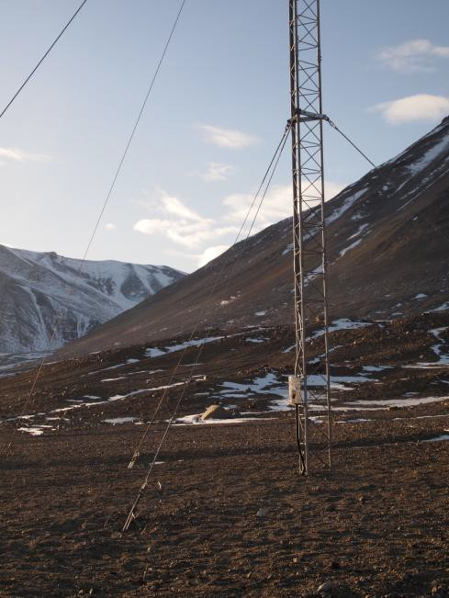

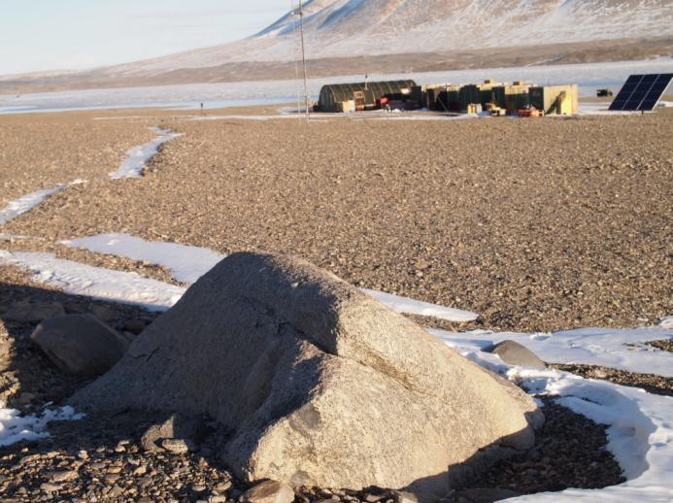

Lake Bonney
Latitude: -77.714530°
Longitude: 162.464800°
Note (23-Jan-15): The benchmark described below is right on the lakes edge (ice was pushing on it when I was there in Dec). The new benchmark, not shown here, is further up the hill, slightly east and uphill of the met station. It’s a big ¾” pin. Unfortunately, images of it were not sent to me yet. Hopefully you can find it.

Benchmark is a pin in a rock labeled ‘medved1’ on a cooper tag, located below and East of the Bonney Met Station.
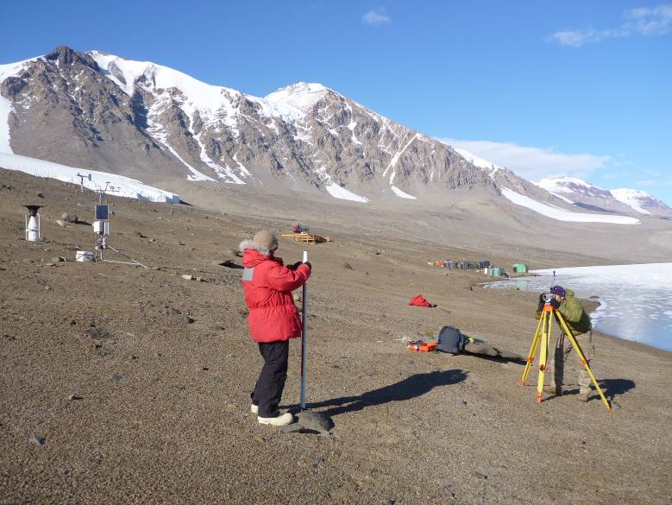
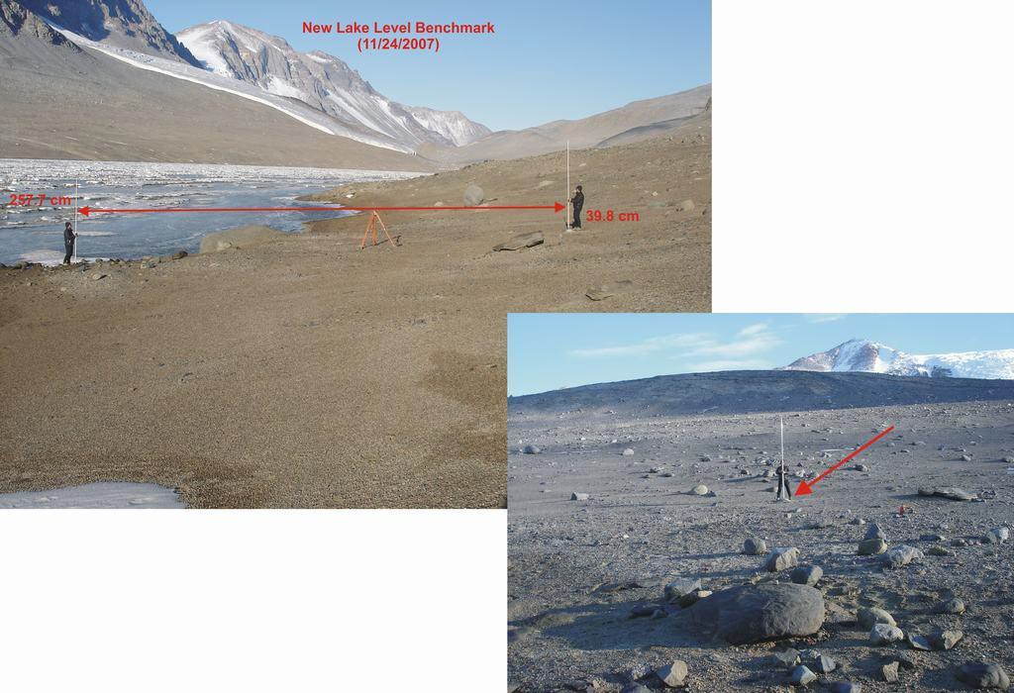

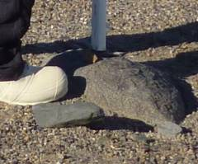

Lake Hoare
Benchmark is located on the way to the old Jamesway (see picture below and ask if you don’t know where it was). There is another benchmark to the right of it established by Chris Jaros (in 2010/11 season). However, we didn’t georeferenc it this season as it was covered by snow during our stay there. Please use the BM that is shown on the picture below. There are many possible bolts, beware! You want to shoot BM-Doran, a nail-type BM. BM-Jaros is a bolt and is 0.44 ft above BM-Doran. BM-USGS “Harry” is labeled as such and is 2.77 ft below BM-Doran.
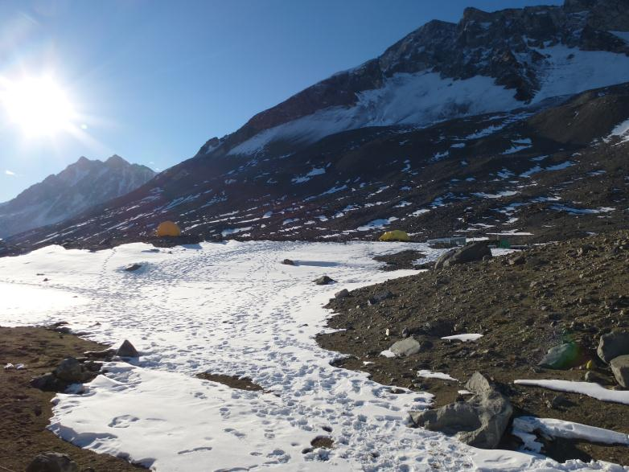
BM-Jaros
BM-USGS
“Harry”
Instrument Lab
BM-Doran

Lake Joyce
Latitude: -77.715403°
Longitude: 161.634699°
Benchmark is a large bolt in a rock, with orange “NSF-USAP-USGS” marker. Benchmark is just west of a small delta formation (which could be submerged) centrally located on the North shore of the lake. This delta should not be assumed safe to land on should it be visible. There is a larger delta about 100 meters to the west of the bolt that was safe to land on in January 2015. Other landing sites are limited to the lake ice itself Alternatively, prepare for a hike!

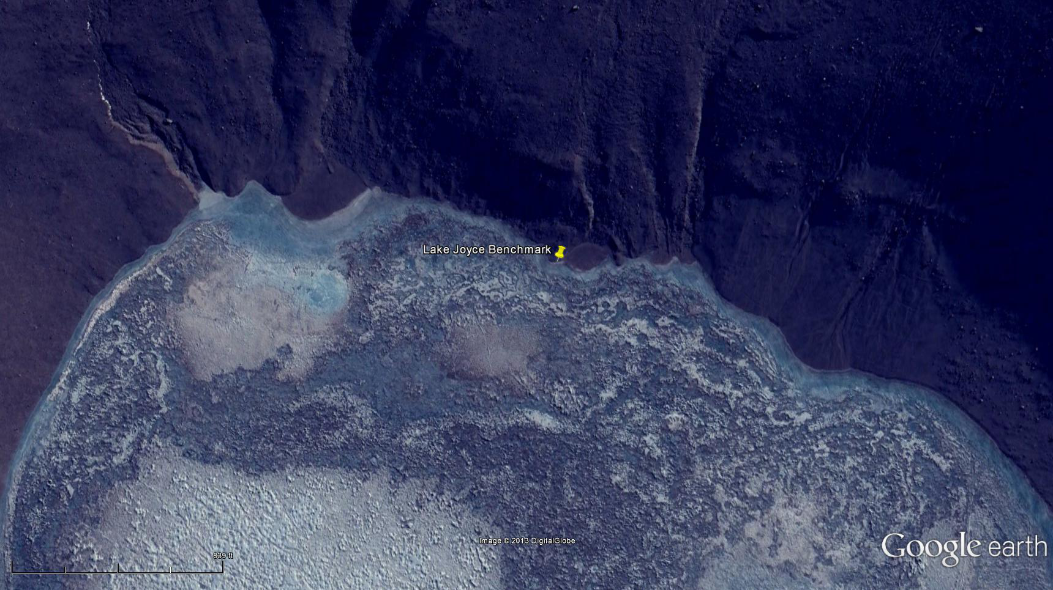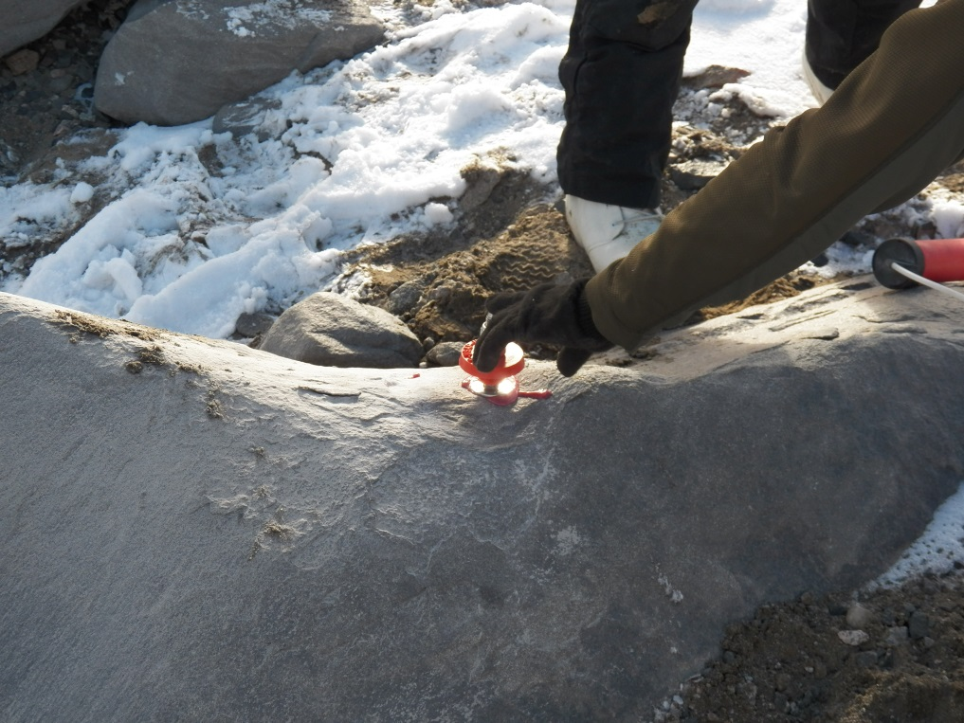

Lake House
Latitude: -77.701587°
Longitude: 161.452423°
Benchmark is a large bolt in a rock, with orange “NSF-USAP-USGS” marker. Benchmark is located East of Lake House, near known landing sites, within 100 m of the lake.
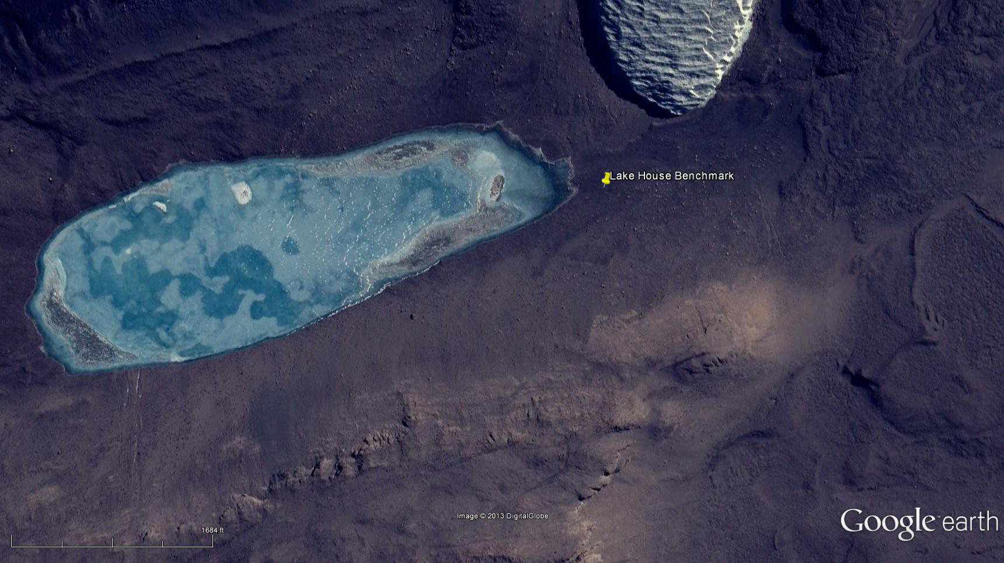
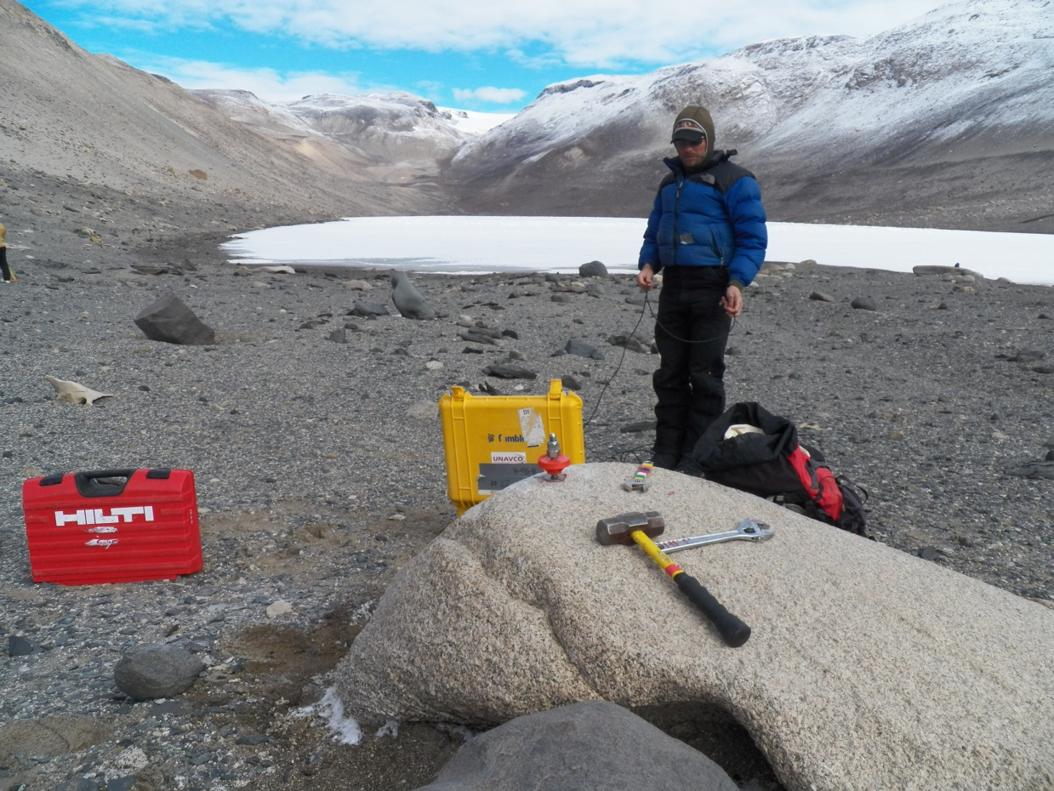

Don Juan Pond
Latitude: -77.563362°
Longitude: 161.180006°
The BM is an obvious metal pipe sticking up out of the pond/water near the edge, about 3 inches in diameter located on the west end of the lake. It is called BM Borehole. You can probably shoot this with close support.
The BM is near the inlet to the pond, so there is flow for some distance after the inflow enters the perimeter of the lake. Pick a location where there is no flow, and hence no gradient to bias the lake level measurement.
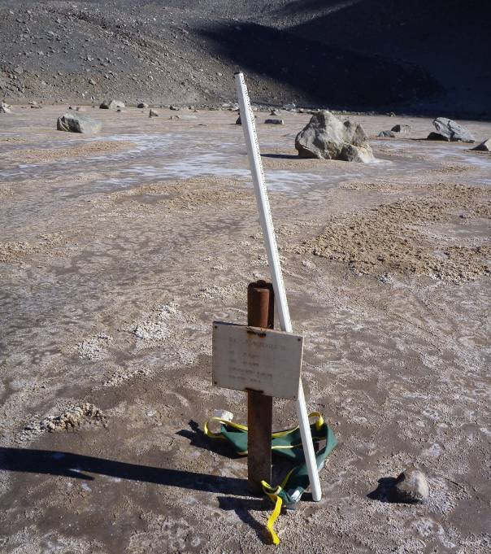
Lake Vanda
Latitude: -77.526222°
Longitude: 161.688806°
Benchmark is a pin in bedrock located on the east shore of the lake, south of the Kiwi camp. There is a dead seal between the lake and the new BM.
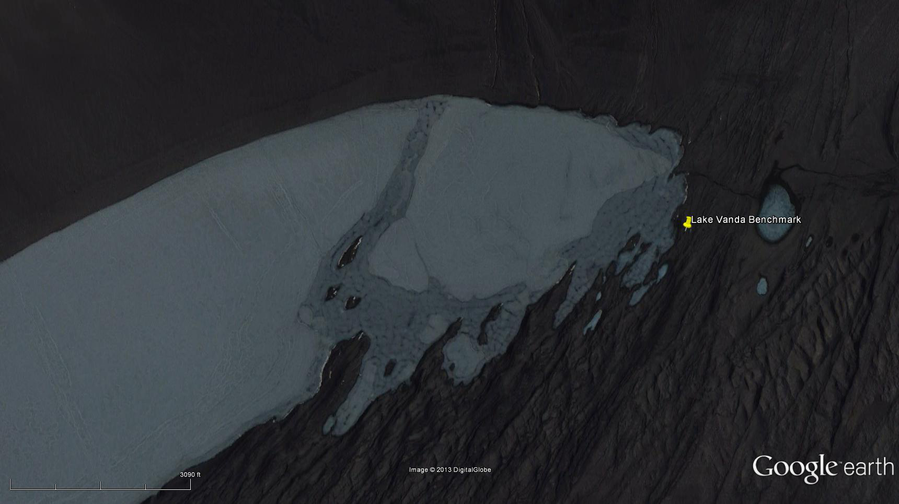

Lake Miers
Latitude: -78.093602°
Longitude: 163.858093°
Benchmark is a bolt located on the north shore of the lake. Kiwis established the BM and its official name is BMM26. In January 2015 the benchmark was within about 5 meters of the lake, much closer than shown in the Google Earth image (see below)..
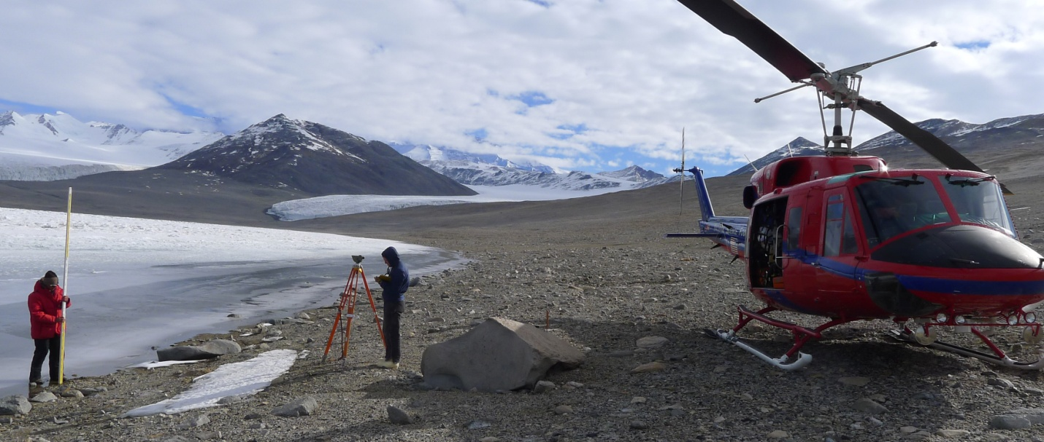
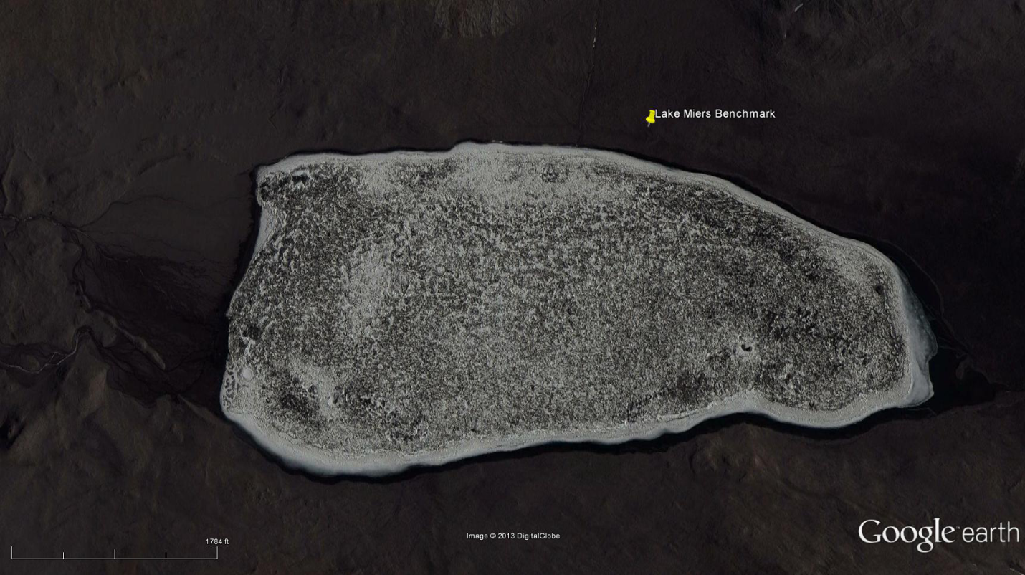

Lake Vida
Latitude: -77.382283°
Longitude: 161.817842°
Benchmark is a pin in a rock off the southwest edge of the lake. You will not likely find it without the coordinates. This location will require a turning point to correctly shoot.
